John Davies ENGL 840 Empirical Research Methods Dr. Fowler-Amato

Initial Data Collection

Research Questions (may require some adjustment):
Is there really a (unusually attractive – may need to remove this language) pull of comics to queer people?

What shape does that take when extended into adulthood (clearly lots of grown-ups, including cishet ones, remain devoted to comics, but is it different for 2SLGBTQIA+ people)?

Is queer comics fandom, on balance, better or worse for agency, empowerment, and social enculturation?

THE PROJECT:
Questionnaire, Reflection on comics artifacts, open-ended “focus group” recorded interview
[First Cycle Open and Axial Coding Using color-coding based on the “progress” rainbow flag for 2SLGBTQIA+ people/ Salient categories determined upon reflection after the data collection and in corroboration with cohort colleagues Alisha, Alyssa, Julie, and Jocelyn]
resistance (against cisheteropatriarchal norms)
empathy
nostalgia
emotive
identity
artistic flair
community
depth of connection
self or hero as “Other”

“Lady Winter”:
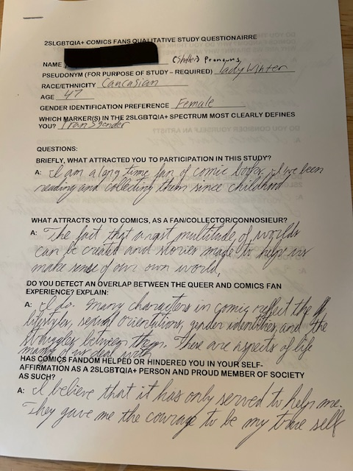
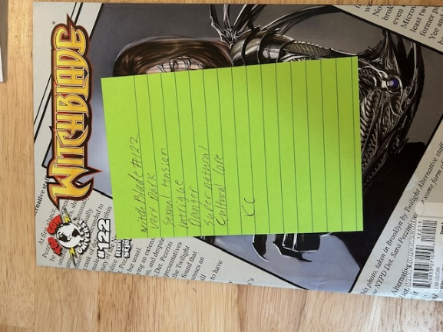
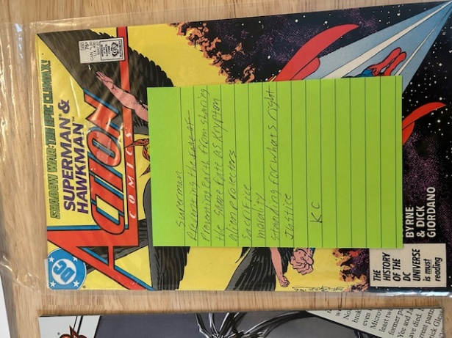
Name(Pseudonym): Lady Winter (she/her)
Race/Ethnicity: Caucasian
Age: 47
Gender Identification Preference: Female
Which marker(s) on the 2SLGBTQIA+ spectrum most clearly defines you?: Transgender
Questions
Briefly, what attracted you to participation in this study? A: “I am a long time fan of comic books. I’ve been reading and collecting them since childhood.”
What attracts you to comics as a fan/collector/connosieur? A: “The fact that a vast multitude of worlds can be created and stories made to help us make sense of our own world.”
Do you detect an overlap between the queer and comics fan experience? Explain. A: “I do. Many characters in comics reflect the lifestyles, sexual orientation, gender identities, and the struggles between them. They are aspects of life many of us deal with.
Has comics fandom helped or hindered you in your self-affirmation as a 2SLGBTQIA+ person and proud member of society as such? A: “I believe that it has only served to help me. They [comics] gave me the courage to be my true self.”
Do you think 2SLGBTQIA+ people in particular are drawn to comics fandom? Why do you think so, or why don’t you think so? Why are we drawn? Why aren’t we? A: “Seeing as that I’m a fan, I say yes, X-Men I believe is a good example. This adds some realism to a somewhat artificially constructed universe.” [/resistance code]
Do you consider yourself an artist? A: “I never have before.”
Do you think there’s an important connection between 2SLGBTQIA+ identity and being an artist? Why or why not? A: “I honestly don’t know one way or the other. I just know that I’ve always been creative.” [sub-code ambivalence]
Does the connection between comics and “queer joy” make sense to you? Why or why not? A: “Yes. Being able to see fictional characters having the freedom to be who they are is inspiring.”
What is “queer joy?” A: “Queer joy to me is deriving happiness from life that others shun or are afraid of.”
Finally, what results do you hope come of this study? A: “I hope that many more representations of the LGBTQ+ community are represented, and help create more understanding and lessen the hate/and stigma.”
Consents:
Consent to be interviewed: Yes.
Consent to be recorded: Yes.
Consent for AI transcription: Yes.
Consent for responses to be used in a limited academic study: Yes.
“Lady Winter”’s comics artifacts responses (post-its):
“Witchblade #122”:
Very dark
Sexual tension
Intrigue
Supernatural
Cultural core
“Action Comics #588: Superman and Hawkman”:
Preventing earth from sharing the same fate as Krypton
Alien protectors
Sacrifice
Morality
Standing for what’s right
Justice
“X-Men vs Apocalypse”:
Struggle for survival
Equality
Hate for difference between other humans
Characters fight for their place in the world
Proving worth
Strong female characters
Outsiders in conflict

“Ceres”:

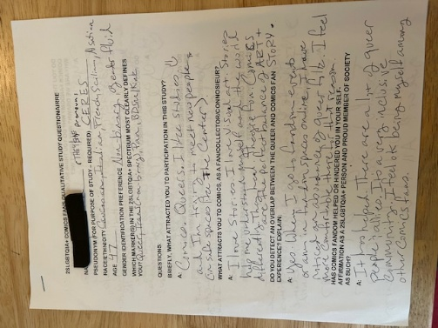
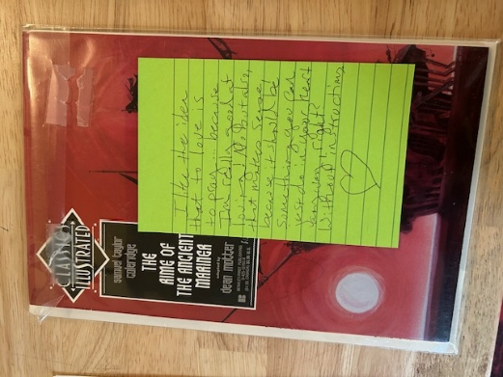
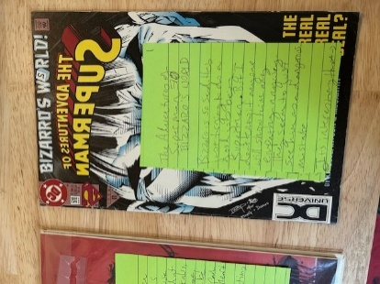
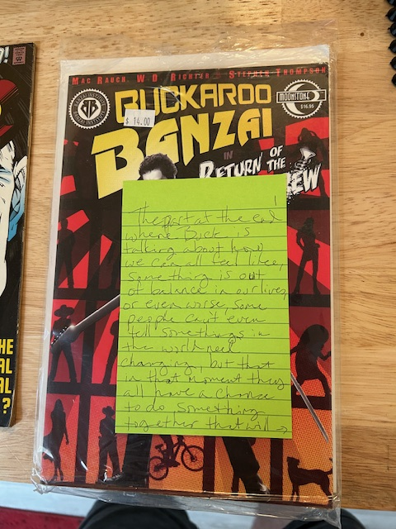

Name(Pseudonym): Ceres (they/she)
Race/Ethnicity: Caucasian, Italian, French, Sicilian, [another I had trouble reading “Alsatian?”]
Age: 47
Gender Identification Preference: Female
Which marker(s) on the 2SLGBTQIA+ spectrum most clearly defines you?: Non-binary, gender fluid
Questions
Briefly, what attracted you to participation in this study? A: “Comics. Queers. I like studies and I’m trying to meet new people (in safe spaces like the Center)”
What attracts you to comics as a fan/collector/connoisseur? A: A: “I love stories. I love visual art. Stories help me understand myself and the world differently. They heal. They’re fun. Comics are the perfect balance of ART + STORY.”
Do you detect an overlap between the queer and comics fan experience? Explain. A: “Yes. When I go to fandom events or am in fandom spaces online, I have noticed an abundance of queer folk. I feel more comfortable there for that reason.”
Has comics fandom helped or hindered you in your self-affirmation as a 2SLGBTQIA+ person and proud member of society as such? A: “It has helped. There are a lot of queer people & allies. It’s a very inclusive community. I feel ok being myself among other comics fans.”
Do you think 2SLGBTQIA+ people in particular are drawn to comics fandom? Why do you think so, or why don’t you think so? Why are we drawn? Why aren’t we? A: “Yes. I’m not sure, but I think one reason might have to do with the struggles of super heroes and villains. Like, I always related to Batman, Harley Quinn, Rogue, but like, because of their human struggles. The things they do as heroes or villains are choices, sometimes inspiring, sometimes warning. You know?”
Do you consider yourself an artist? A: “YES” “Writer, Visual Art, Most Art”
Do you think there’s an important connection between 2SLGBTQIA+ identity and being an artist? Why or why not? A: “Yes, because self-expression is so important to understanding yourself and communicating, and our community needs that so much. Also I think queer people are just drawn to art.”
Does the connection between comics and “queer joy” make sense to you? Why or why not? A: “Yes, because there’s a lot of inclusivity in comics, and a lot I can relate to even if it’s subtle sometimes. I feel quite a lot of queer joy in the comic world.”
What is “queer joy?” A: “Feeling joyfully queer? Joyful about queerness? Joyfully understood about being queer? All that.”
Finally, what results do you hope come of this study? A: “Hmmm. … more comics and more queers for everyone! I think this connection should be acknowledged and implemented by schools, parents … I mean give the queers comics, right?”
Consents:
Consent to be interviewed: Yes.
Consent to be recorded: Yes.
Consent for AI transcription: Yes.
Consent for responses to be used in a limited academic study: Yes.
“Ceres’s” comics artifacts responses (post-its):

“Classic Illustrated: Rime of the Ancient Mariner”:
I like the idea that to love is to pray … because I’m really good at loving!
No, but also that makes sense because it should be something you can just do in your heart
anyway, right? Without instructions.

“The Adventures of Superman: Bizarro’s World”
Bizzaro is so sad. He’s just trying to do a good job being Superman.
But I don’t know if anyone will show him any empathy anyway. They seem to just see him as a
dangerous mistake. It’s interesting that Bizarro thinks Lois should always be in danger, because it’s his job to save her. Ah, and the filing of sexual harassment lawsuits looks so easy here. If only it really worked like that. At the end, Lois tells Superman she doesn’t need to be saved. I wasn’t expecting Bizarro to be about this accidentally abusive Superman who wants Lois in damnger so he can save her. I like that she gets out of it on her own. I think the bit about sexual harassment at the news studio was well-intentioned but naïve. I like that it encourages women to report harassment, but it sets up an expectation for immediate justice. Oh. Wait. Right. Comic book. Ok. I guess it makes sense?
… but these kinds of stories weren’t helpful to me when reporting in real life [it] was actually really hard and no one listens to you.
“Buckaroo Banzai: Return of the Screw”
The part at the end where Buck is talking about how we can all feel like something is out of balance, or even worse, people can’t even tell something in the world needs changing, but that in the moment they all have a chance to do something together that will help; it’s how you show people they can help change the world. Also his talk about being adrift from our true natural course reminds me of transcendentalism.

This respondent tended to move back and forth between personal connection and generalization, an observation to revisit on a future round of coding perhaps.
Considered “ambivalence” as a code, but it didn’t seem to repeat as a theme often enough. Book-marking this response as well.
It’s worth noting that the post-it note responses could have constituted codes in their own right. They also might have been opportunities for “in vivo” coding. I felt that, by keeping the codes from the more formal questionnaire, the consistency in evaluation might reveal certain inconsistencies between how queer fans abstract their love of comics and how they engage in actual comics-reading.
This response was interesting because it was a mini-essay all on the space of one or two (large) post-its. It demonstrated how a comics story about an experience a fan knows about first hand can occasion both connection and disconnection. I wonder if “more conventional” literature would occasion a similar ambivalence, if the ambivalence is more down to having experienced the event or seeing it depicted in comics form. This Bizarro comics story was the artifact with which this particular respondent engaged most.

