John Davies
Dr. Michelle Fowler-Amato
ENGL 840: Empirical Research Methods
11 May 2026

DIGITAL PORTFOLIO AVAILABLE AT:

https://www.qcfsstudy.com/portfolio

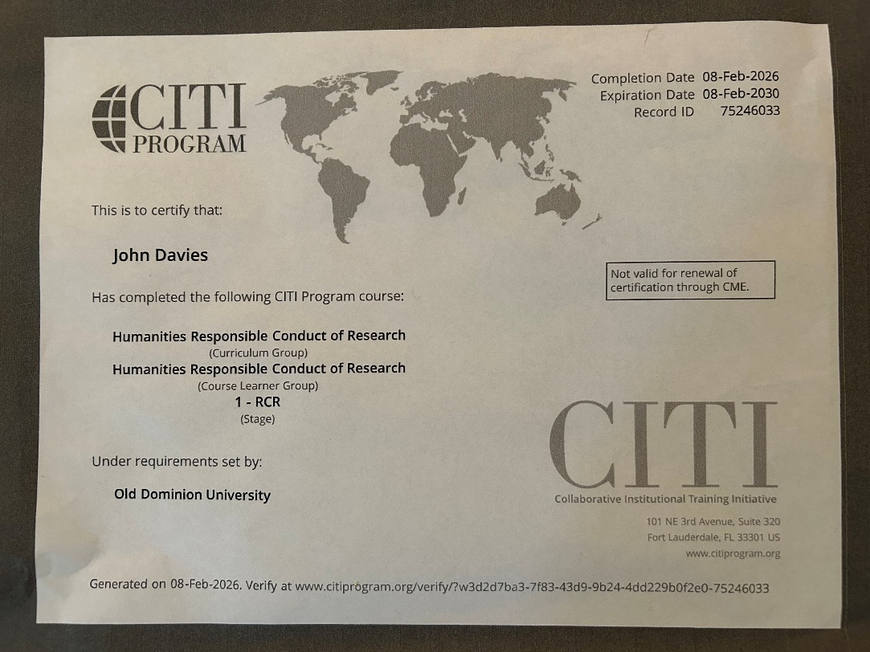

Small-Scale Qualitative Inquiry Project Plan
PLAN SUMMARY:
On March 14th, 2026 I will convene a cohort of 2SLGBTQIA+ comic book fans at my community’s Sexuality and Gender Difference Cultural Center. I have partnered with the Center in recruiting respondents, using both social media/networking and physical flyers. This presents some ambiguity going into the study with regard to racial, cultural, and age demographics as well as number of participants, though we are aiming for between 6 – 12 people (likely on the low end of that). The flyers foreground the concept of Queer Joy, so it may be expected that respondents resonate with that subject in relation to their comics fandom. Participants will peruse and remark on comics artifacts, discuss the artifacts and their fandom history in a recorded rap session, with guiding questions and participate in an exit interview to encapsulate topics not covered in the social or focus group activities. The hoped for outcome is to get some insight into queer comics fandom, specifically the agency, social enculturation, and personal empowerment embodied in that intersection.
CONCEPTUAL FRAMEWORK
The best synopsis I can offer for my conceptual framework is “comics as a site of queer joy.” This represents an emergent understanding as my life experiences have coincided with my research interests as a comics scholar. Like many young people I discovered comics as a child and pre-teen, as my sexuality and gender identity was forming. I’ve sensed in retrospect that the themes of secret identity, dysphoria, and otherness exemplified in comics narratives resonated with me in a particular way, into adulthood. Scholars like Ramzi Fawaz, Hillary Chute, and Alison Bechdel have taken up this connection, and the mid to late 2010’s saw an increase in 2SLGBTQIA+ artists and writers at the major publishers, Marvel and DC, with characters like Wiccan, Batwoman, and Superboy “coming out” as gay or bi. My dissertation will propose comics as an afterlife of Romanticism and an opportunity for a new critical idiom, but the subtexts of queer fandom and queer joy will undergird that thesis. This empirical study represented by my project plan will be an opportunity to look at those themes in a lived, grounded way.
TOPICAL RESEARCH
The research closest to my theses that I have found has been mostly in the form of Master’s theses and PhD dissertations, which might indicate an emerging trend in scholarly research. The article that affected me the most was about another community, Modern Orthodox Jewish women. The article, “Reconsidering Religious Gender Normativity In Graphic Novel Adaptations: A Quantitative and Qualitative Case Study” by Talia Hurwich narrates a focus group style study with many of the features, like in-the-moment reflection on comics texts, that I intend to use. It is also part of a scholarly conversation on otherness in the Jewish context that overlaps at several points with queer otherness. And it represented an “aha” moment for me in advance of my dissertation research, that religious ambivalence has been the engine of Romantic survival.
FORMAL THEORY
I tend to apply a hodgepodge of theories to my scholarly work, on the premise that classical approaches (in the sense of “old,” not literally ancient) like formalism and romantic-aesthetic have more to offer than is sometimes acknowledged and late twentieth century theories like postmodernism and poststructuralism need to be interrogated more deeply than they often are. There are theories I have begun to encounter that would inform my project if I were more well-versed in them. They are phenomenological theory, affect theory, and grounded theory. Some foundational texts are Maurice Merleau-Ponty, Phenomenology of Perception (which I have seen referenced in comics scholarship); Eve Sedgwick and Adam Frank’s Shame in the Cybernetic Fold (affect theory), and Grounded Theory: A Practical Guide by Jane Mills and Melanie Birks. These have been added to my to-read list.
THE PLAN IN STAGES
APPROACH:
My approach falls at the midpoint of basic qualitative research and mixed methods research (Tisdell 75 – 86). I saw “mixed methods” largely because that is how Hurwich (mentioned above) characterized her study, and I intend to do some of the same things (like graphically depict the demographic results, for instance).
RESEARCH QUESTIONS
◆ Is there really an unusually attractive pull of comics to queer people?
◆ What shape does that take when extended into adulthood (clearly lots of grown-ups, including cishet ones, remain devoted to comics, but is it different for 2SLGBTQIA+ people)?
◆ Is queer comics fandom, on balance, better or worse for agency, empowerment, and social enculturation?
SAMPLE:
3 – 12 self-selected individuals of multiple ages (all adult), genders, and racial-ethnic background who self-select based on response to advertising
DATA COLLECTION
◆ Observation of subjects with artifacts, recorded roundtable conversation, written and spoken interviews
QUESTIONS
Other than the need for humility in absorbing new information that will benefit the study, the only holistic question I have is: should not enough people arrive for the activity, can I switch the research design to something more like an interview (or something else)?

Works Cited
“Grounded Theory: A Practical Guide Birks Melanie and Mills Jane Grounded Theory: A
Practical Guide 208 Pages £26.99 Sage 9781446295786 1446295788 [Formula: See Text].” Nursing Standard, vol. 30, no. 7, October 2015, pp. 28–28, https://doi.org/10.7748/ns.30.7.28.s31.
Hurwich, Talia. “Reconsidering Religious Gender Normativity in Graphic Novel Adaptations: A
Quantitative and Qualitative Case Study.” English Teaching : Practice and Critique [Hamilton], vol. 20, no. 2, July 2021, pp. 180–95, https://doi.org/10.1108/ETPC-08-2020-0097.
Merleau-Ponty, Maurice. Phenomenology of Perception. Routledge, 2002.
Sedgwick, Eve Kosofsky, and Adam Frank. "Shame in the Cybernetic Fold: Reading Silvan
Tomkins." Critical Inquiry, vol. 21, no. 2, 1995, pp. 496–522. JSTOR, doi.org.
Tisdell, Elizabeth J, et al. Qualitative Research: A Guide to Design and Implementation. Fifth
Edition, Wiley, 2025

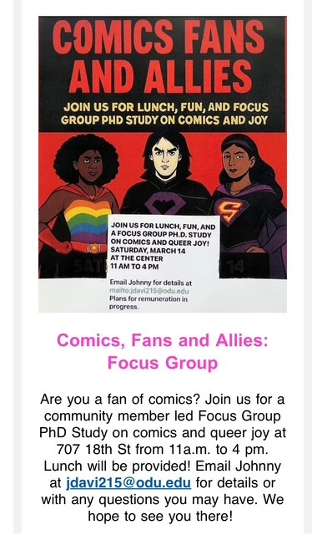
Positionality Memo

I am going to try to compose my thoughts with relative formality, as that is how I think best. The first thing I have to say about my positionality, which I may repeat later in response to one of the specific questions posed on the assignment prompt, is that I live directly within the community I am studying. I am studying queer comics fans, and I am a queer comics fan. I also have very specific hypotheses which I hope to demonstrate in my study, which I will have to monitor closely and hold to a high disciplinary standard. I am hoping to show, both in this study and my dissertation project later on, that the comics milieu is a revenant of Romanticism and that comics’ queer fanbase responds to this tendency in the medium in particular, and that this says something both about the cultural impact of comics and the continuing (revived?) relevance and utility of Romanticism.
My project is in its earliest stages. I have secured a space in which to conduct a focus group, my community’s Sexuality and Gender Difference Center. I have created posters for the event, which have been posted physically and which the Center’s director has agreed to post virtually (I removed myself from social media and networks three years ago). I do not yet have any respondents. I intend to participate in the activities of the focus group day, but I do not intend to log my responses to the questions I will pose. I may do so separately from the finished project, in my journals.
The assignment prompt poses six questions.
- “How does who I am, who I have been, who I think I am, and how I feel affect the research process?” (Pillow, 2003, p. 176)
I have a series of biases to be aware of. The most obvious is that I am a queer comics fan with my own beliefs and assumptions about that connection. Less obvious is my conflicted stance on academic research and certain atmospherics in the academy. Clearly it is a “place” I love to be. Quite apart from the current pressures being exerted by the presidential administration, which I consider vile, I think the academy could benefit from more internal review of how it absorbs cultural theory and which approaches it privileges and considers legitimate over others. I prefer “reality is a social contract” to “reality is a social construct.” I prefer reconstruction to deconstruction. I prefer synthesis to conflict. I actually think my respondents might be more in line with academic thinking on these premises than I have been, which complicates the “Romantic” stance I hope to see reflected in the research. I need to be more open to changing my mind on tightly held assumptions, which is a challenging place to be.
- “Where are ‘self’ and ‘subject’ joined? (Pillow, 2003, pp. 181-184).
In a real way I exemplify my subjects, though I suspect my focus group attendees will be younger than me. So, the answer may be “identical,” and if not identical at least closely adjacent.
- “How will I recognize the ‘other?’” (Pillow, 2003, pp. 184-185).
That is difficult because I think of myself as quite “other” in many ways, some culturally elided ways like age. I need to think deeply and seek guidance when opportunities arise to do the work of genuine allyship when it comes to BIPOC comics fans. I can’t assume an identical experience, nor can I assume differences at times that individuals who fit this description note similarities. Also, I may have gotten too familiar in assuming the experience of lesbians and trans people. These are all opportunities for self-interrogation.
- “How will I negotiate ‘truth?’” (Pillow, 2003, pp. 185-186).
Well, a core value I hold is that truth is experiential rather than propositional or declarative. The truest truths I expect to glean from this experience will have to do with the affective, phenomenological, and subjective responses of the people involved in the study. I might conclude, based on the enthusiasm expressed over certain comics artifacts, that my Romanticism theory has been supported. But, I am not sure that it will be possible to make any objective claims about that. Here is another opportunity to attempt to clarify my positionality: I view myself as an existentialist rather than a postmodernist, two systems that can very easily get conflated at a distance. You can be an existentialist Romantic. Can you be a postmodernist Romantic (I do intend on naming the system I hope to identify in my dissertation Postmodern Romanticism, for reasons that I hope will become clear despite these contradictions)? Truth is subjective, but not an illusion. My conclusions ultimately will be that my respondents had the experience that they said they had.
- “How will I engage in an ‘examination of power relations in the research act itself?” (Merriam and Tisdell)
I want to be humble. I want to recognize streams of privilege in my positionality as a middle aged white man. I want the participants to do the research as much as possible. There is a power imbalance in research, but a big claim in the background here is that fan communities empower themselves in spite of whatever the culture around them is doing, including the culture as expressed in this research project.

Data Memo Directly After Focus Group Activity

This process has been fascinating and work-intensive, with very few guarantees, something that learning about qualitative research has helped me to appreciate. In preparation for the focus group event, I contacted my local 2SLGBTQIA+ Cultural Center, secured a date and space and time, and (with some assistance from ChatGPT since I am not an artist) created flyers, which went up at the local community college, the local state university, and the Center itself. The Center also advertised in their e-mail newsletter and their social pages. Regardless, I had no idea what to expect in terms of number. One person e-mailed me (and suggested she might bring friends), and one person ran into me at the Center and excitedly shared the news of their hoped for involvement. The second person also suggested they might bring friends. These interactions seemed to be predictive of success, because word was getting out, but technically I only had two RSVPs.
Nevertheless I arranged catering (turkey and Vegan sandwiches) because the flyer promised that. I purchased a digital audio recorder. I had my comics artifacts which participants would be interacting with; it was my own collection. Shortly before the event was to take place, the first respondent reached out to me to give regrets. Her transportation fell through. Unsure of the research protocol I answered instinctively “I’ll pick you up!” The person turned out to be a very friendly person my age, gender fluid, female presenting, and lived two blocks from me. Offering a ride worked out, thank goodness, because indeed only the single other person who had RSVP’d arrived. It was a focus group of two (three because I participated).
What a fascinating conversation though! The comics-reading portion was replete with “noticings,” the most significant of which was the highly verbal and immersive interactivity of the readers. I heard quiet reader-laughs, deep murmurings of identification, and expressions of surprise. Reader orientation was leaned-in, brows furrowed, a very literary stance (indeed one of the two readers holds an English Literature degree). I noticed things about the artifacts themselves. I had never before given serious thought to the prevalence of the color red in comics art. It makes sense visually. Red pops. Red is also the color of passion, blood, romance, death, violence, vitality, anger; later we got in a long conversation about red-head female characters in comics, maybe the starkest example being Jean Grey, the PHOENIX, a potent metaphor of sex and danger. These themes emerged:
♦ trauma
♦ identity
♦ shame
♦ progressive resistance
♦ “queer joy”
♦ cultural legitimacy/illegitimacy
♦ visual art as a literacy tool for visual learners
♦ the multiverse
♦ comics as BDSM allegories
♦ the ambiguities of privilege
♦ personal growth in middle age
♦ changes in view as to what constitutes “maturity” from adolescence to middle age (participants were 47, 47, and 52).
I had some difficulty figuring out the audio device, but I was able to successfully use it and download the audio from our conversation (now looking for tools to transcribe it online).
Concerns:
♦ that some questions might have been too leading.
♦ that perhaps there were not enough structured questions
♦ that the methodology will be difficult to label accurately, since the researcher (me) is still in many ways a novice.
Big takeaways:
The relevance of trauma studies to comics studies
the prevalence of themes of equity and agency in modern comics
the immersive interactivity of comics reading (here is where I would like to do more research on phenomenological theory, affect theory, and grounded theory).
I am more convinced than ever that comics are a site of Romanticism.

Post- Qualitative Data Analysis Lab Memo
I was struck by the richness of the qualitative method in the “lab” setting, especially as a researcher relatively new to these processes. I came to it recognizing that my methodology had not been perfect. My questions may have been too leading at times. The inclusion of a “conceptual framework” in the data set that we analyzed might militate against the emergence of our coding, I feared. Maybe I was “theming” too early? The extraordinary thing about research involving people is that something will always be revealed that one did not expect. I look forward to honing my objectivity and practicing these methods with increasing rigor. I had good data to draw from. My participants in the “queer comics fans” focus group were exceptionally forthcoming, a font of codes (I may have to go back and look at trauma as something that came up multiple times). Beyond that, the serendipity of my participants’ biographical similarity could yield something. Both were 47 and identified on the transgender spectrum. This was born out in my bibliography as well; I found several published articles of empirical research of the trans experience in comics fan spaces.
In my breakout group on Zoom, I was placed with Alyssa, Alisha, Jocelyn, and Julie. These four colleagues looked at the post-it note reactions that my research participants placed on their comics. We had about ten minutes of individual reflection on the data followed by a session of democratic coding. I brought a set of tentative codes, but removed three of them when my colleagues contributed “resistance,’ “empathy,” and “identity.” Our codes lived in a space of abstraction, but an appropriate one I think for the grounded approach I think I may be approaching. Fans are expansive in their naming, and I wanted to honor that. We color-coded our categories (codes) according to the 2018 “progress flag” created by Daniel Quasar to honor racial, ethnic, and gender diversity in the 2SLGBTQIA+ experience.
Here is what we came up with:
resistance (against cisheteropatriarchal norms)
empathy
nostalgia
emotive
identity
artistic flair
community
depth of connection
self or hero as “Other”

We went through the post-its and questionnaire responses and highlighted words and phrases with these colors. Near the end of our session Jocelyn noticed something that she named “radical alterity,” the queer embrace of a wholly other that is well-reflected in comics characters who are “other” at a genuinely alien dimension. Many words and phrases cut through several of our namings. In some instances we placed new emergent categories that we hadn’t color-coded in brackets to be considered later: ie [self-reflexivity] [performativity and inauthenticity in the “real world”]. At one point in the semester I was apprehensive of coding and asked about the allowability of AI assistance (a practice I had been wary of up to this point). Now that I am confident I can achieve manual, analog coding I have been experimenting with using those tools at the stage of graphic representation only, which might look something like this:
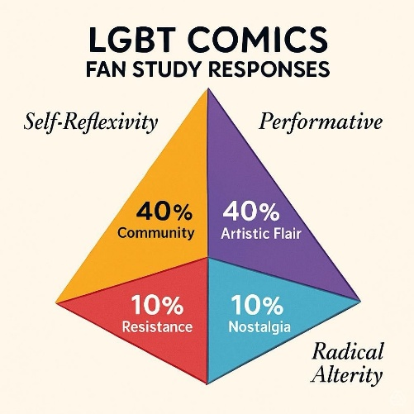(ChatOn Image, Apple)
I already have a website where those little bots added superfluous bells and whistles, but also allowed me to store photos from the actual focus group day and a little video featuring the research questions:
qcfsstudy.com
The preliminary coding, aided by my colleagues, was fruitful and promising. I sensed that at least the structure of constant comparative analysis -- axial coding - theming was beginning to take place.
I look forward to participating in the forthcoming data analysis labs and continuing to tweak, reconsider, reconfigure expectations in relation to my own.

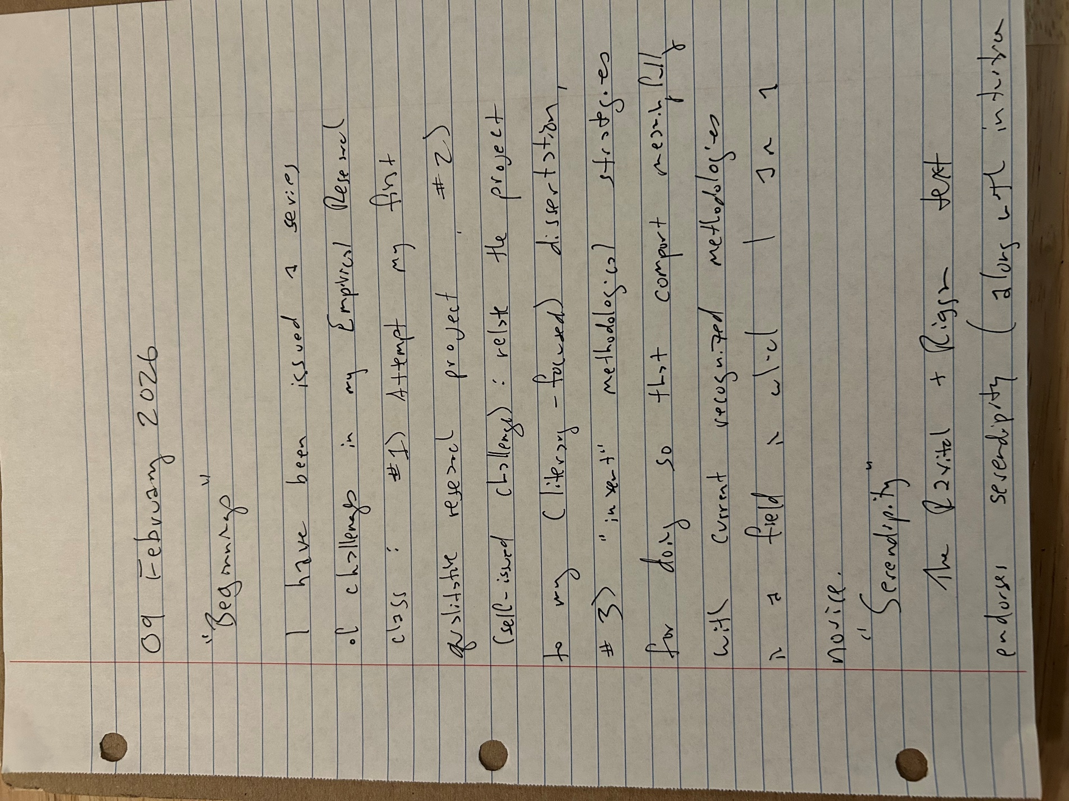
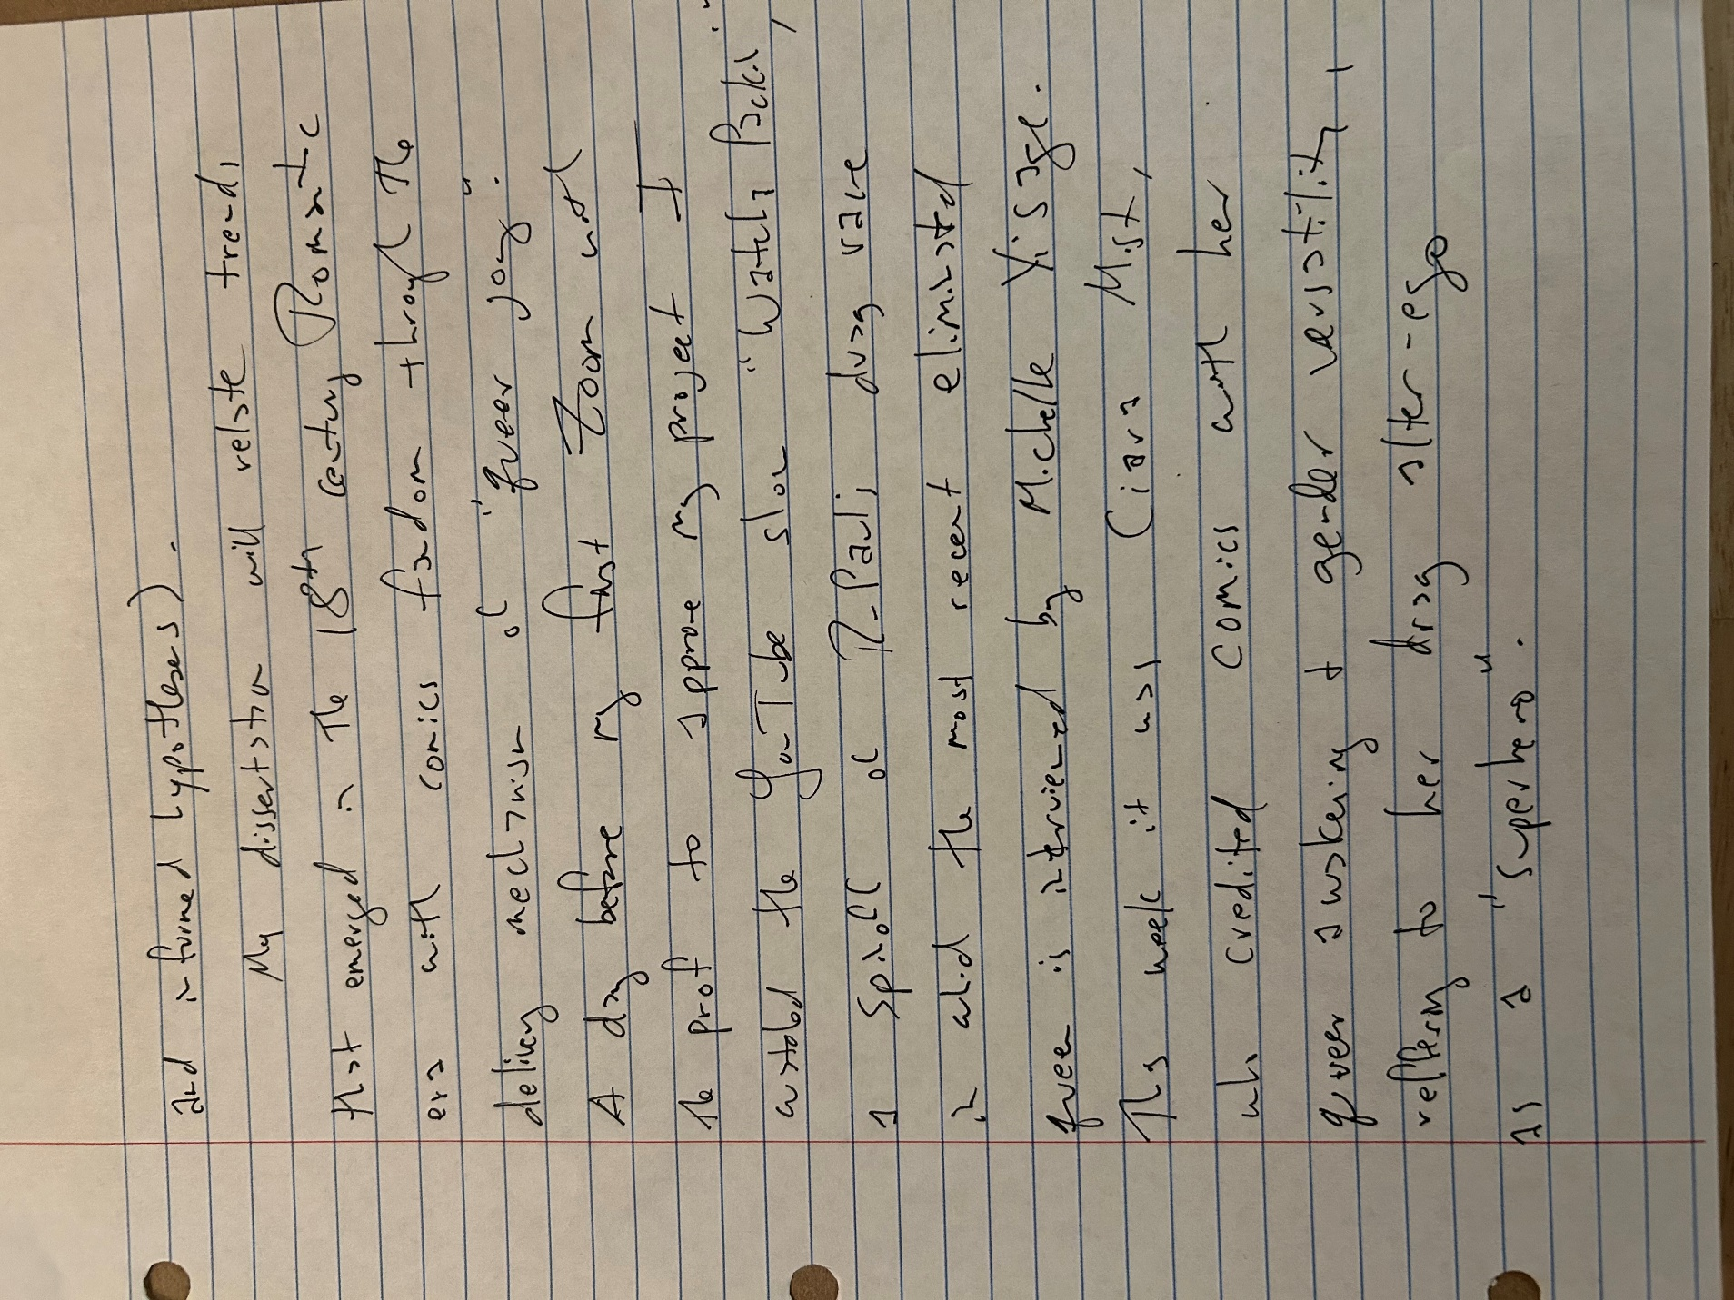
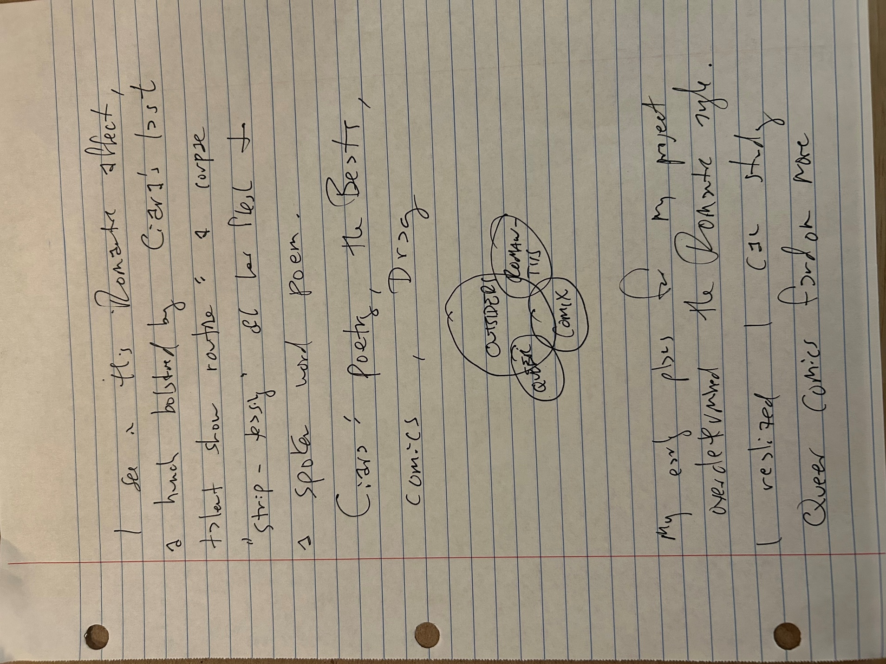
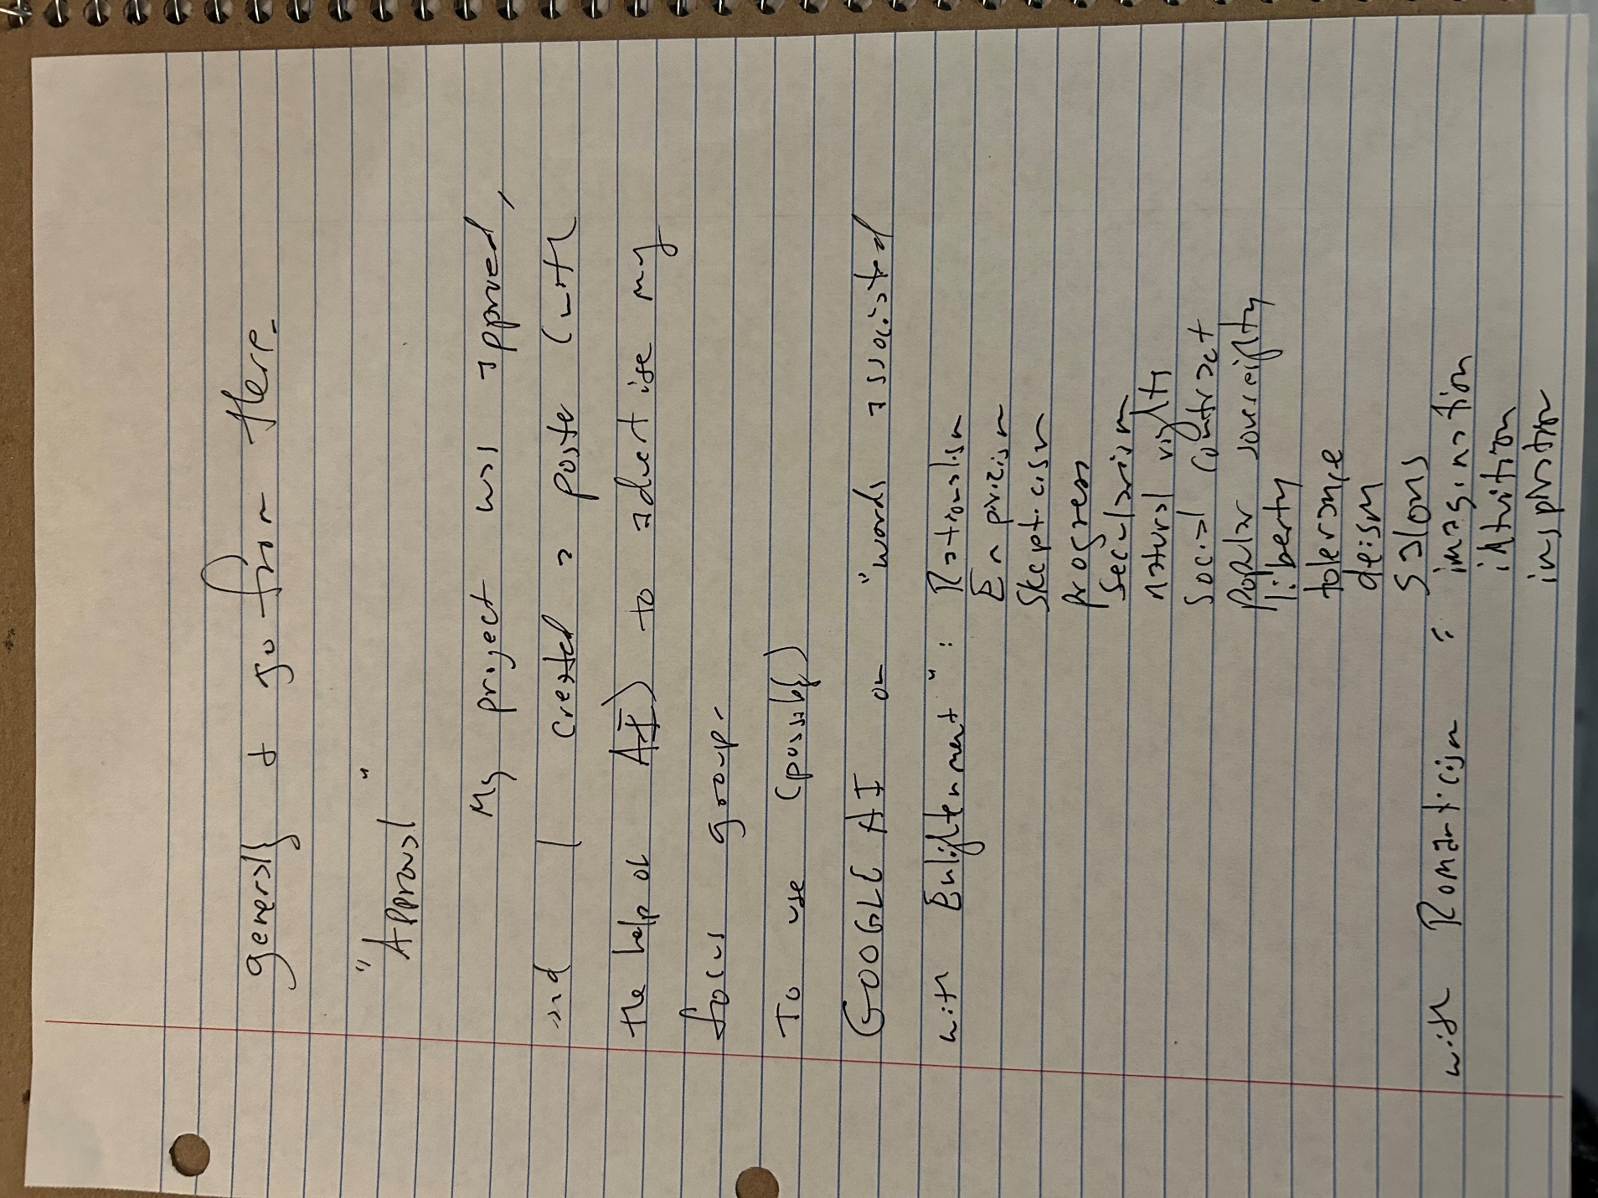
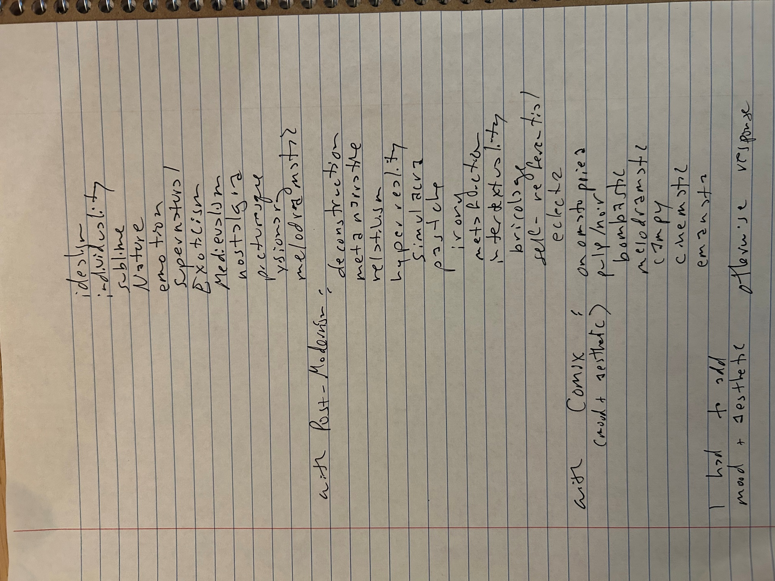
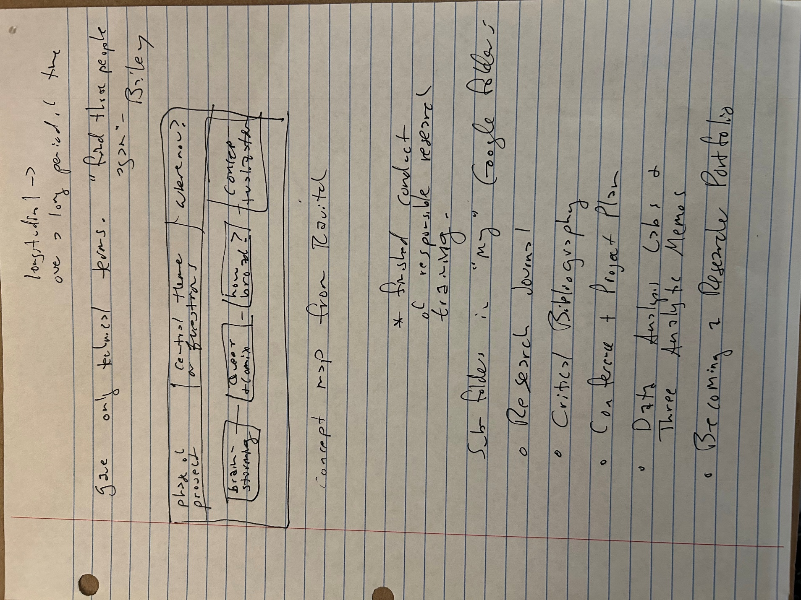
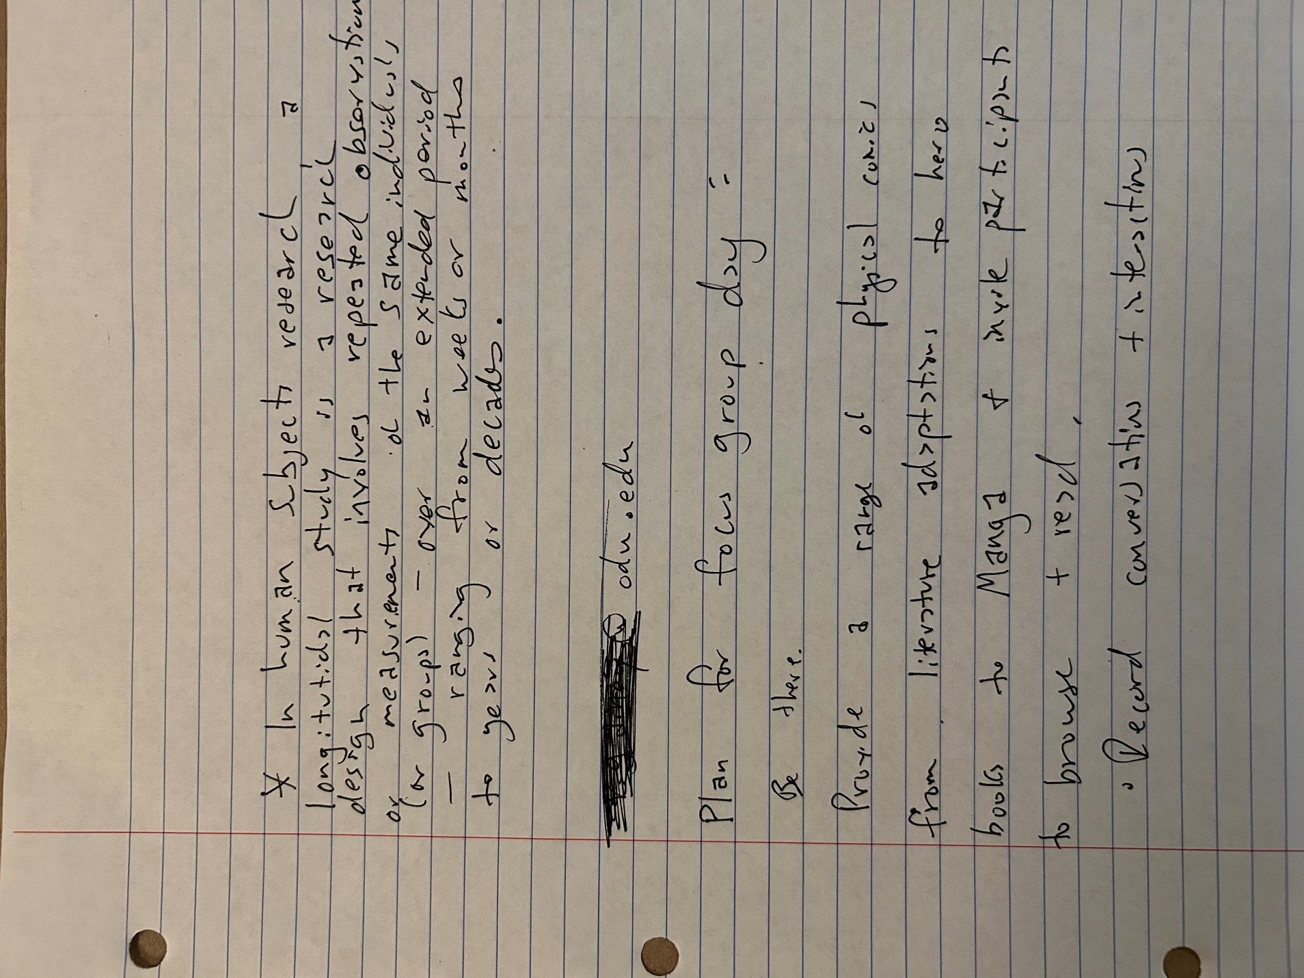
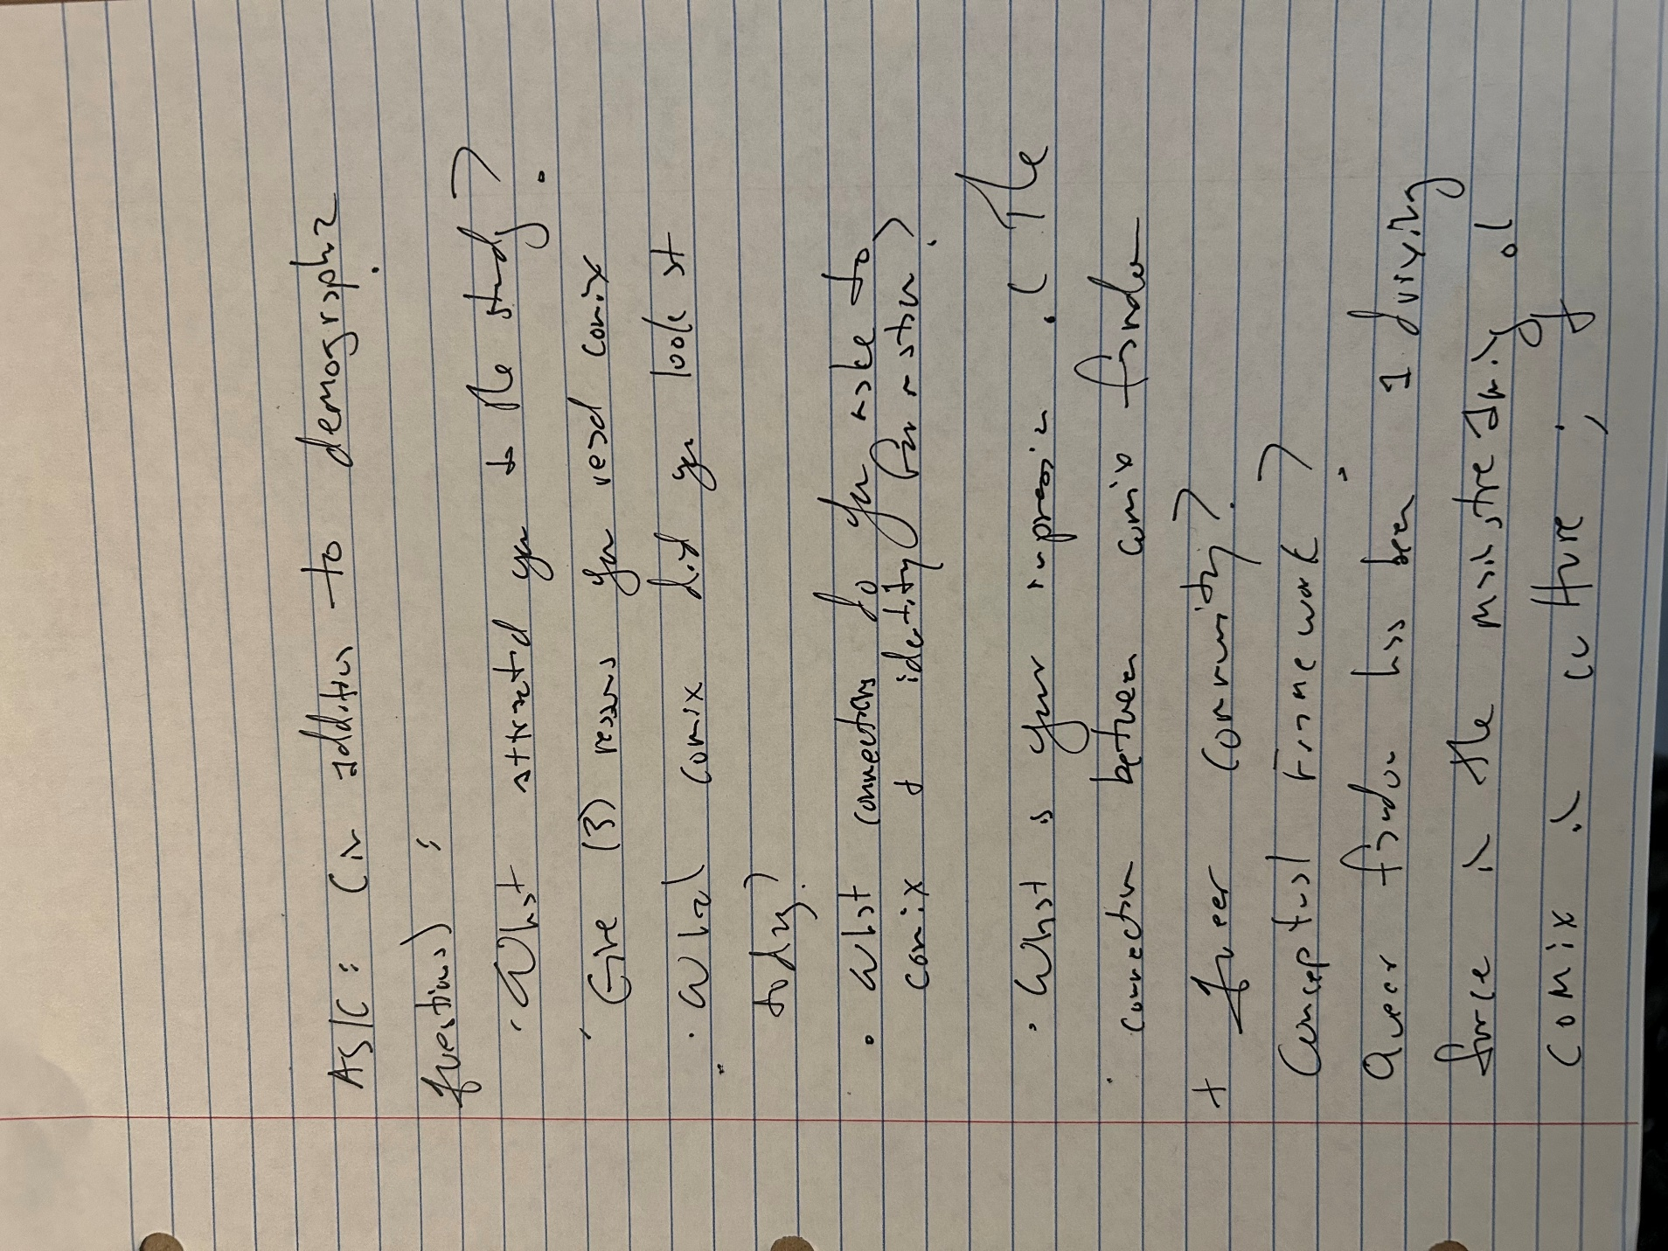
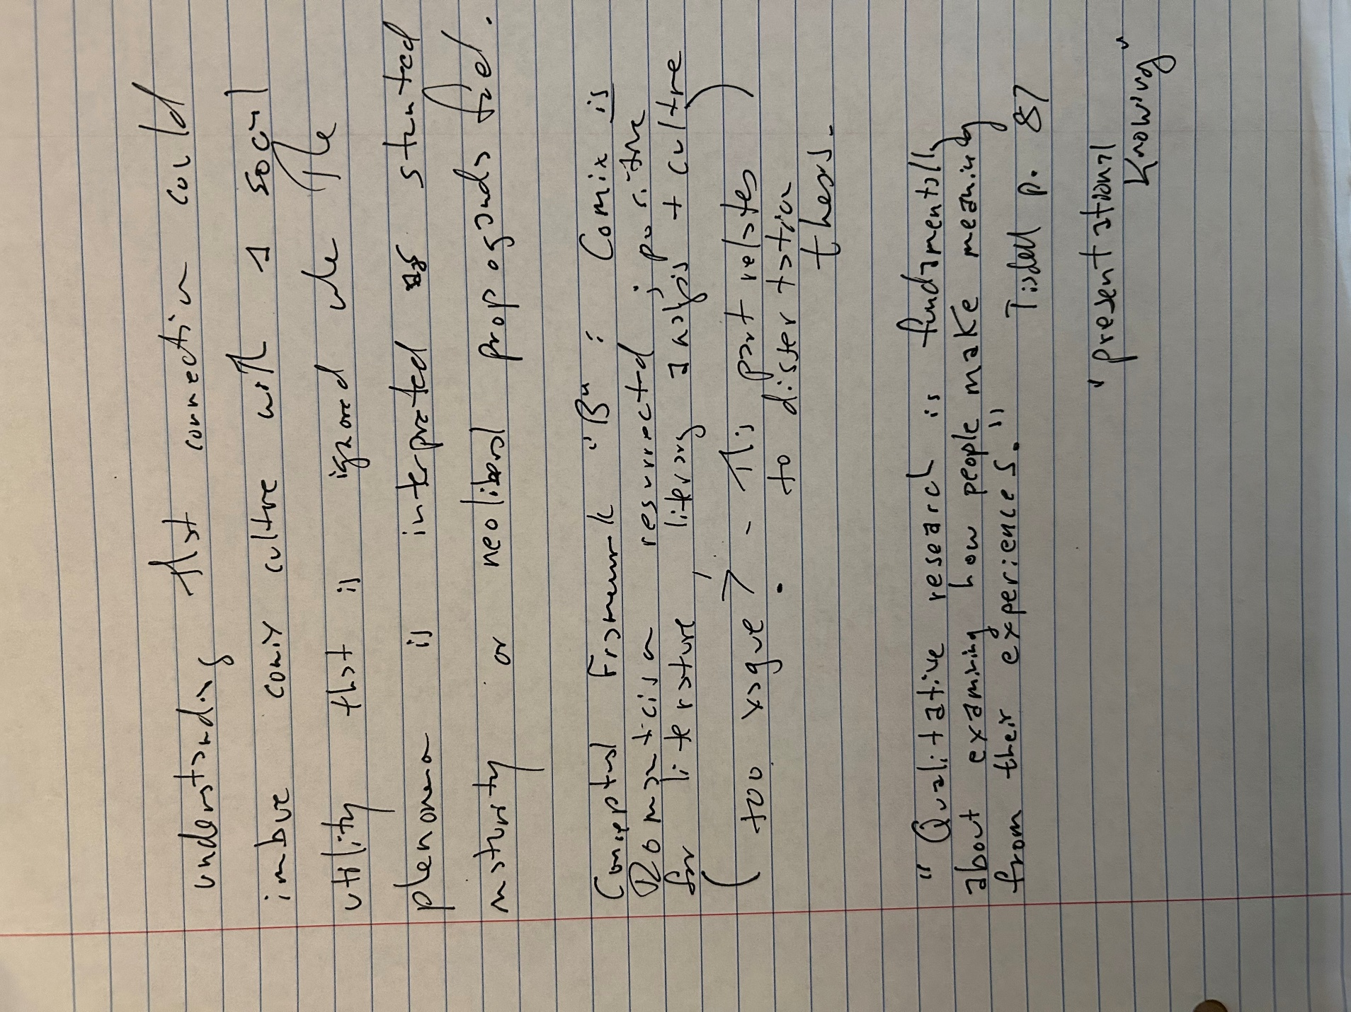
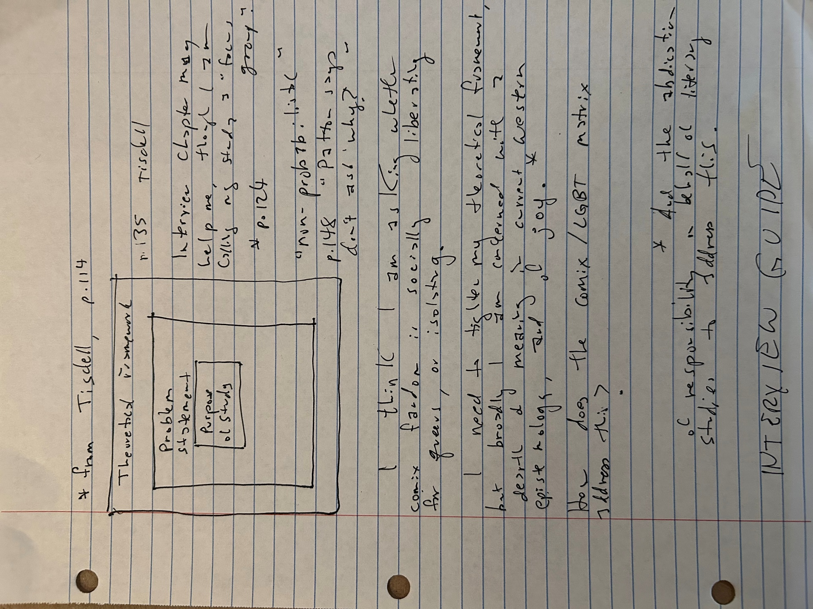
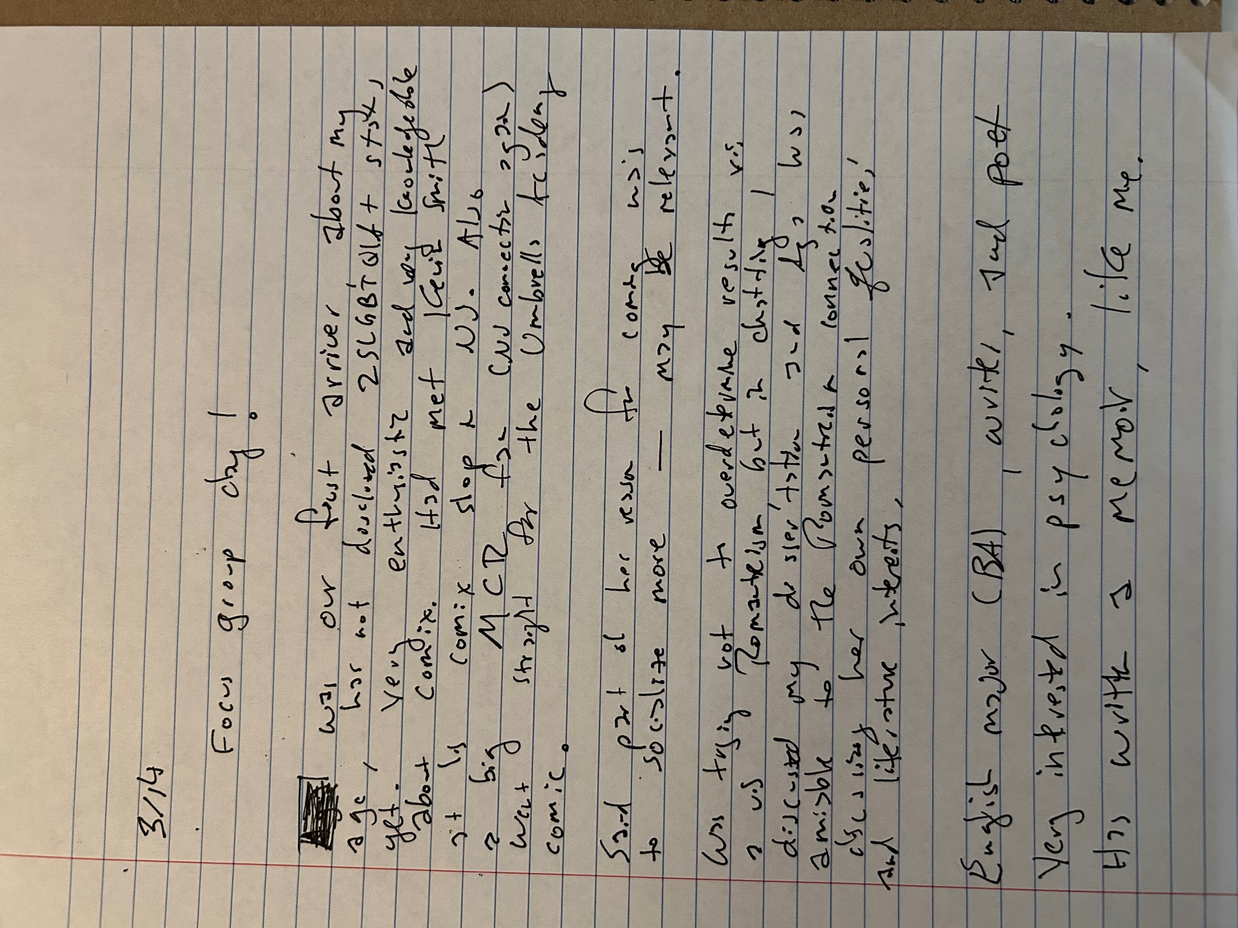
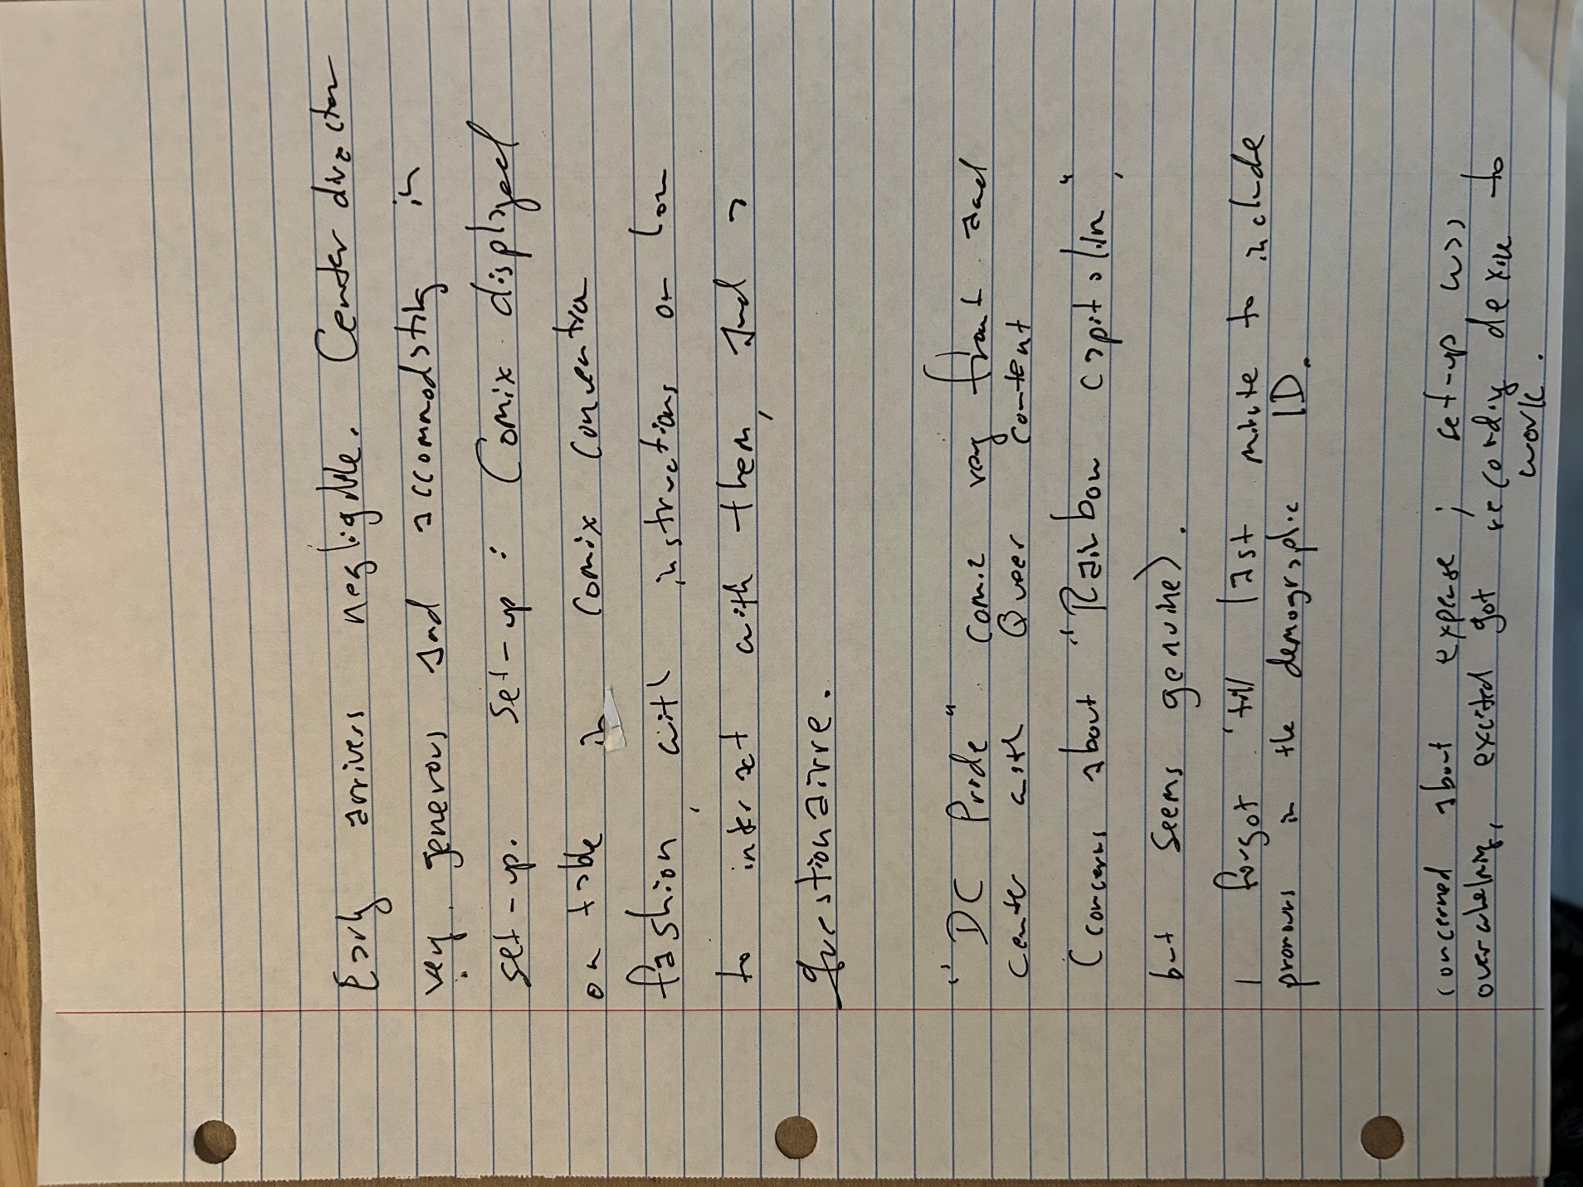
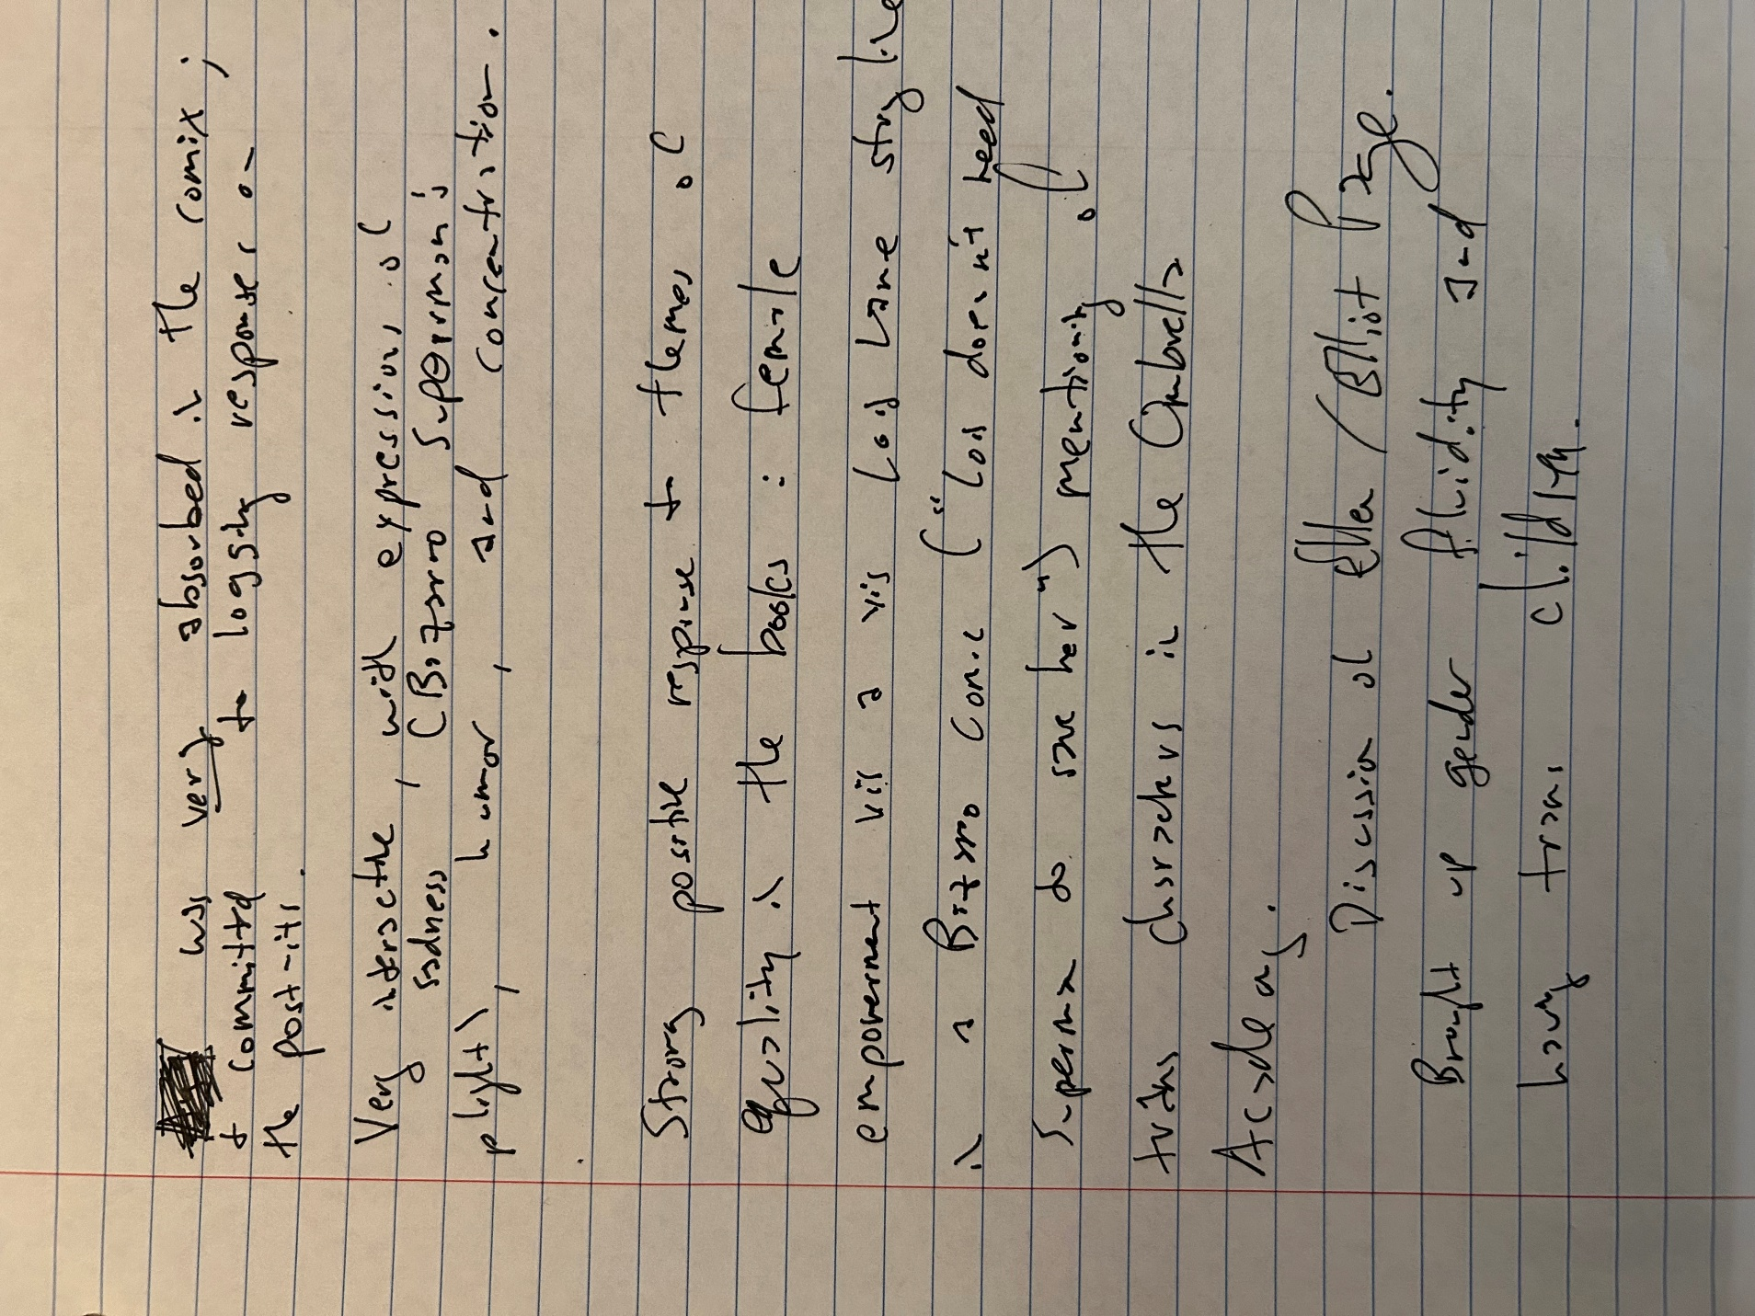
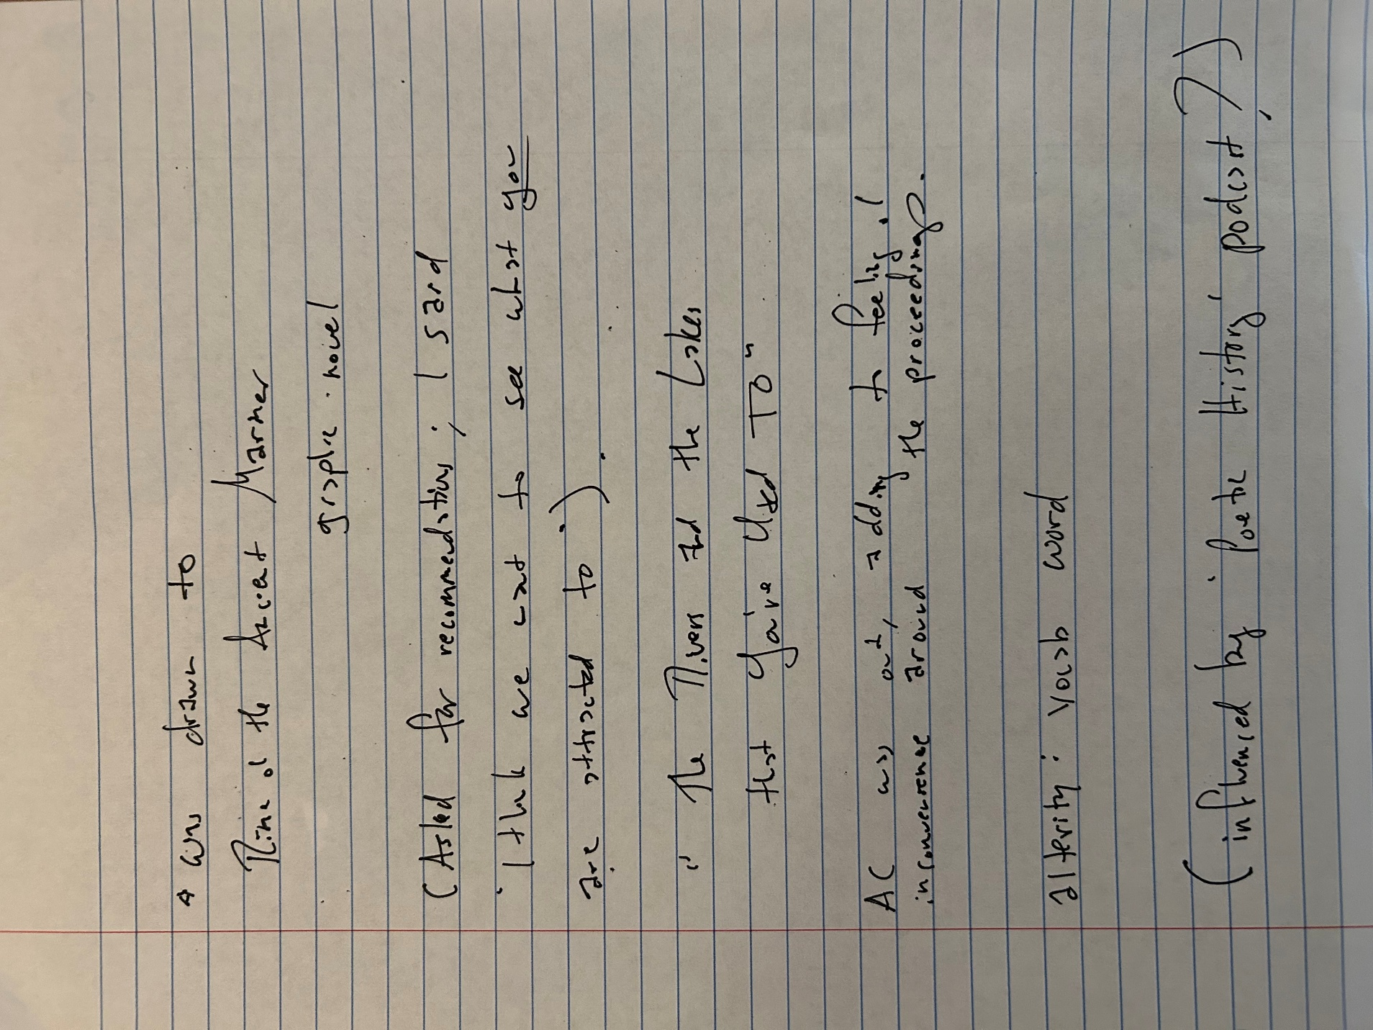
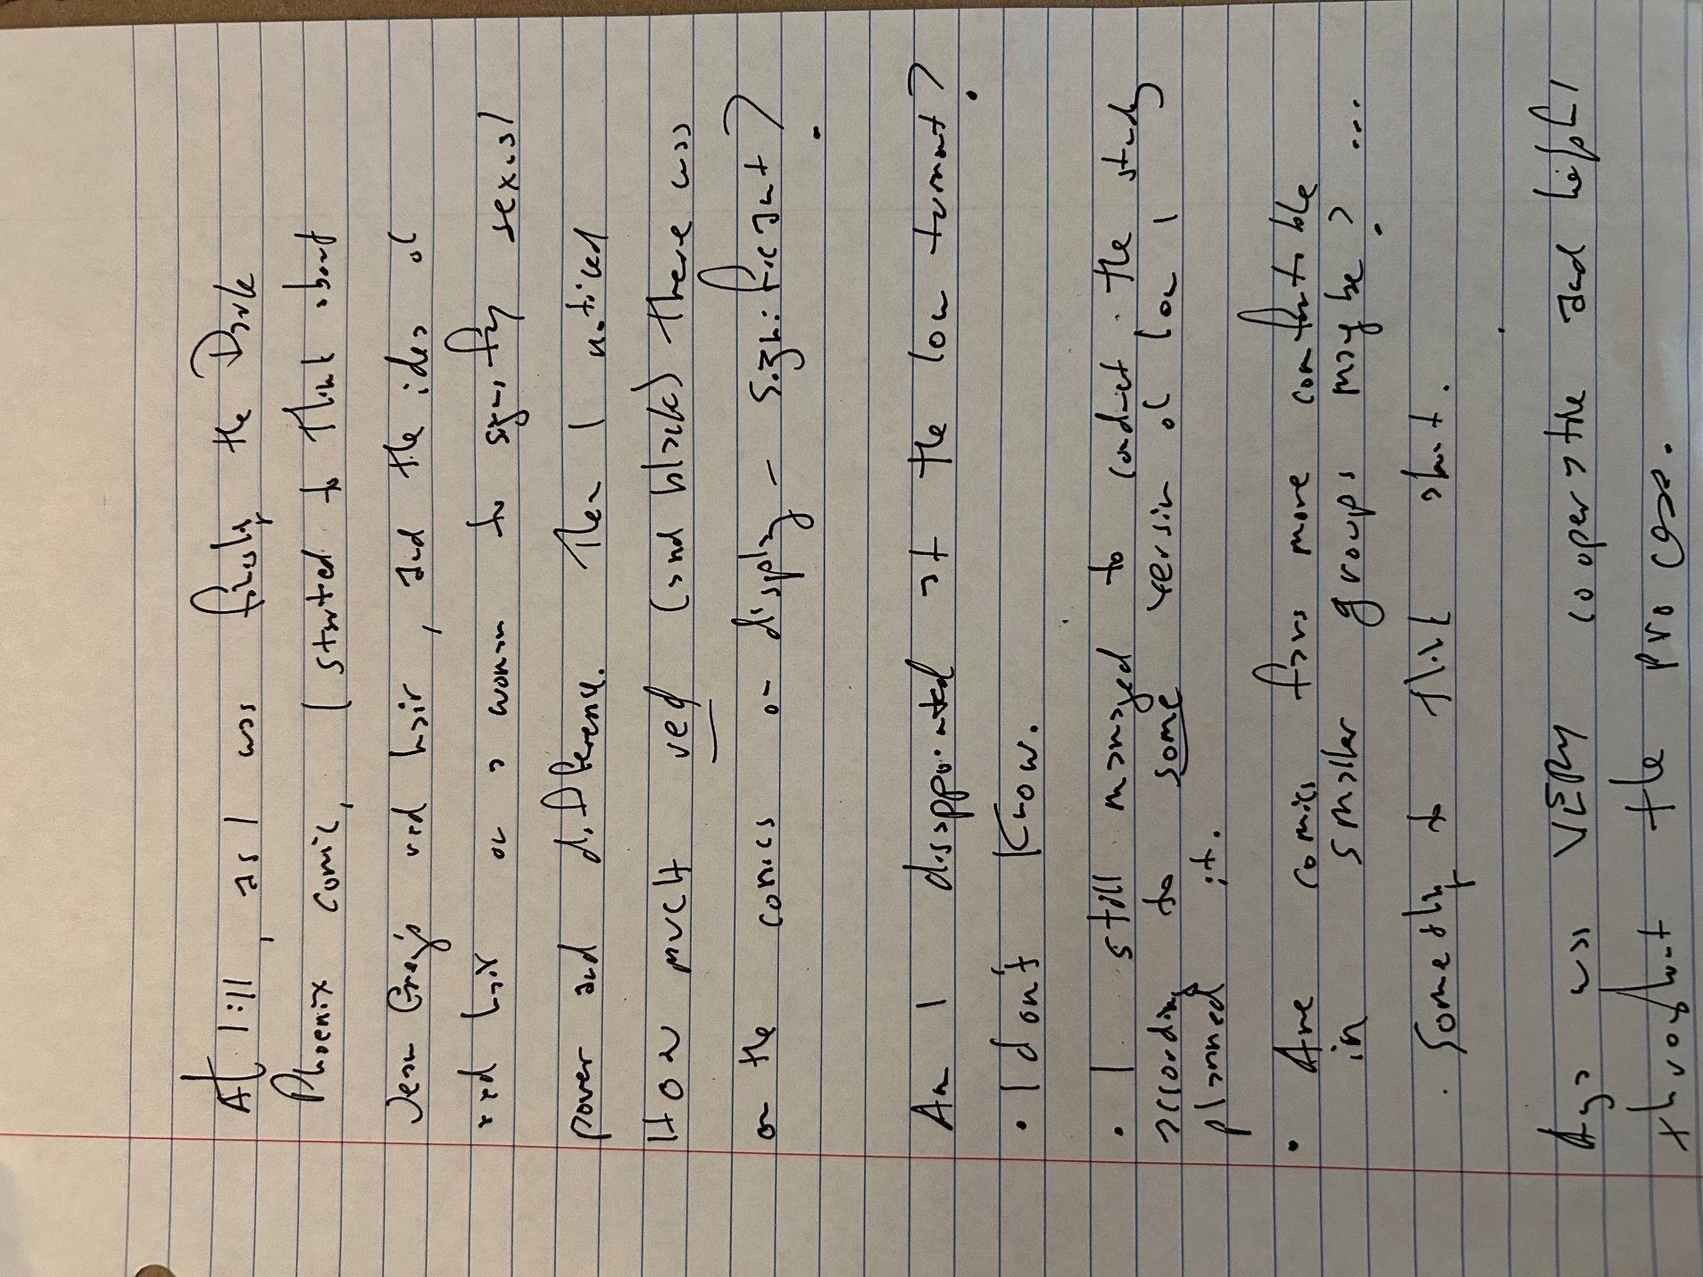
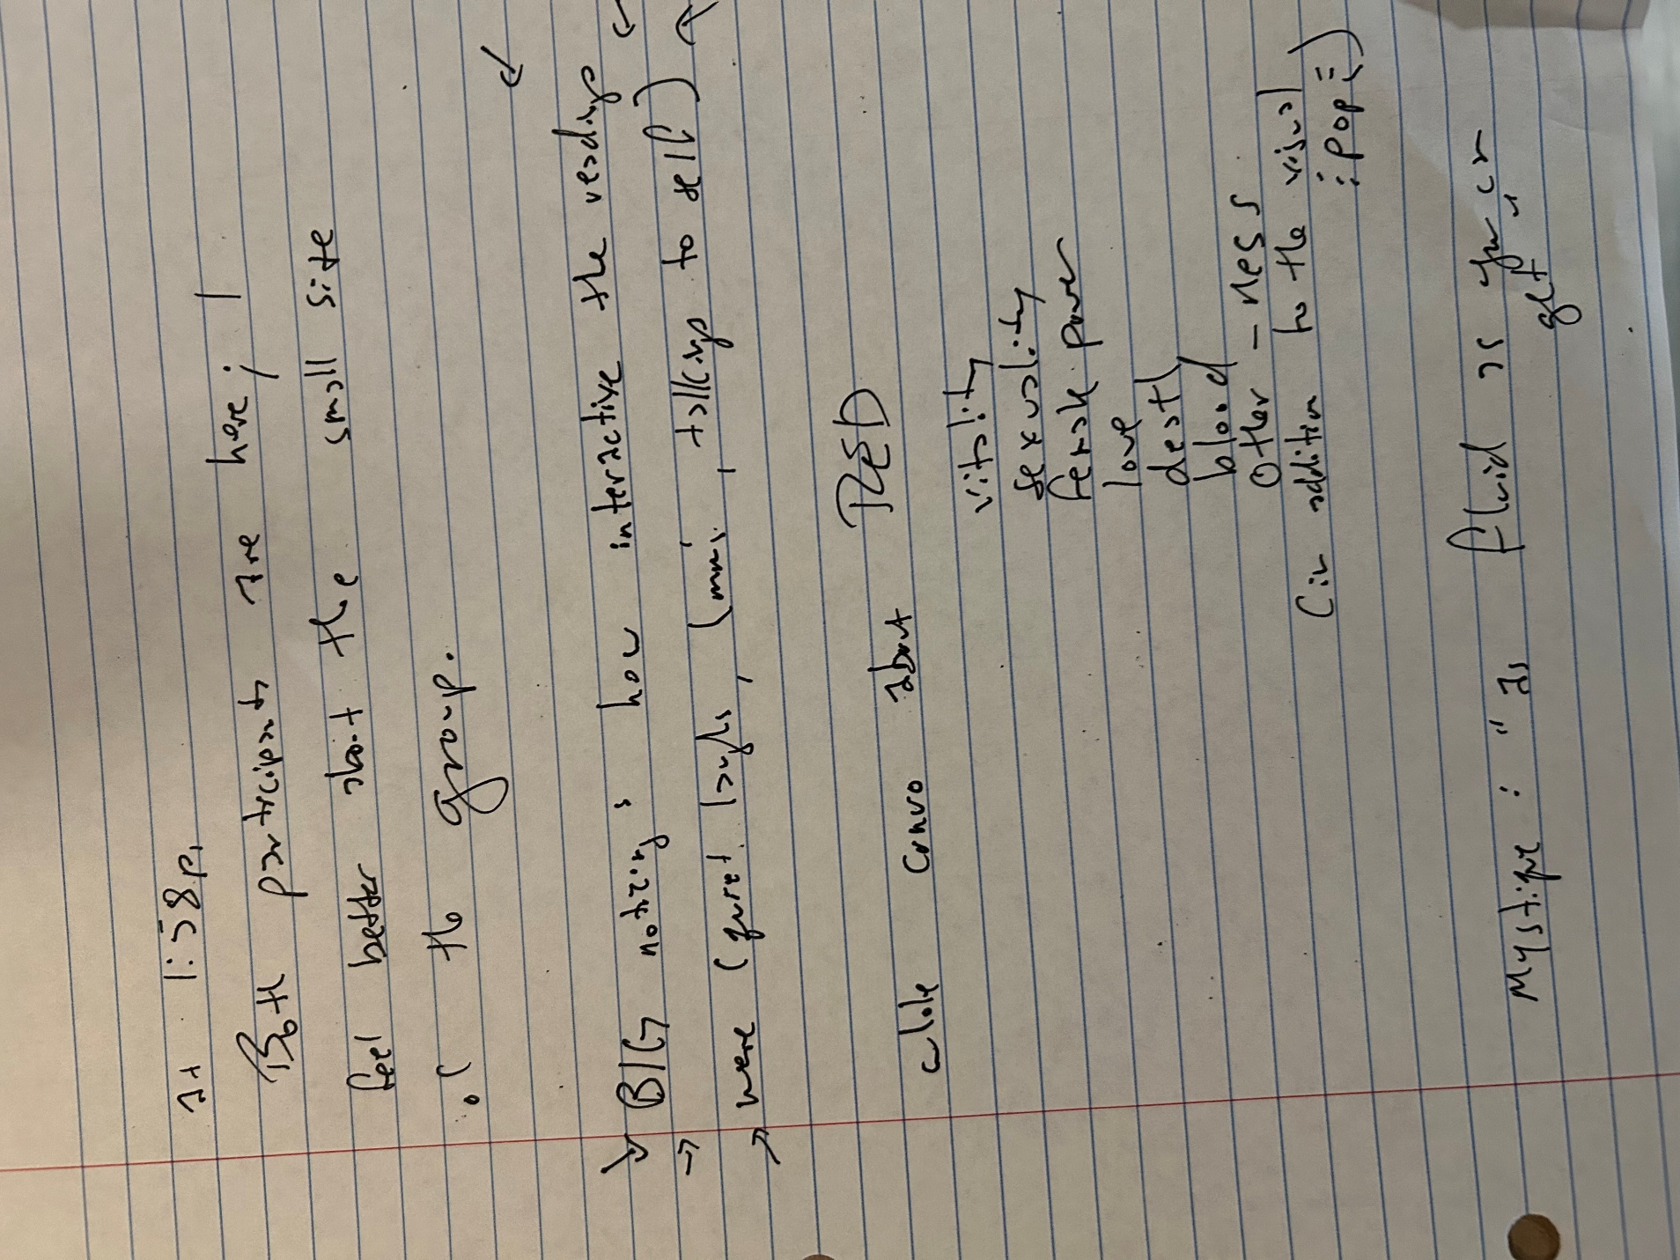
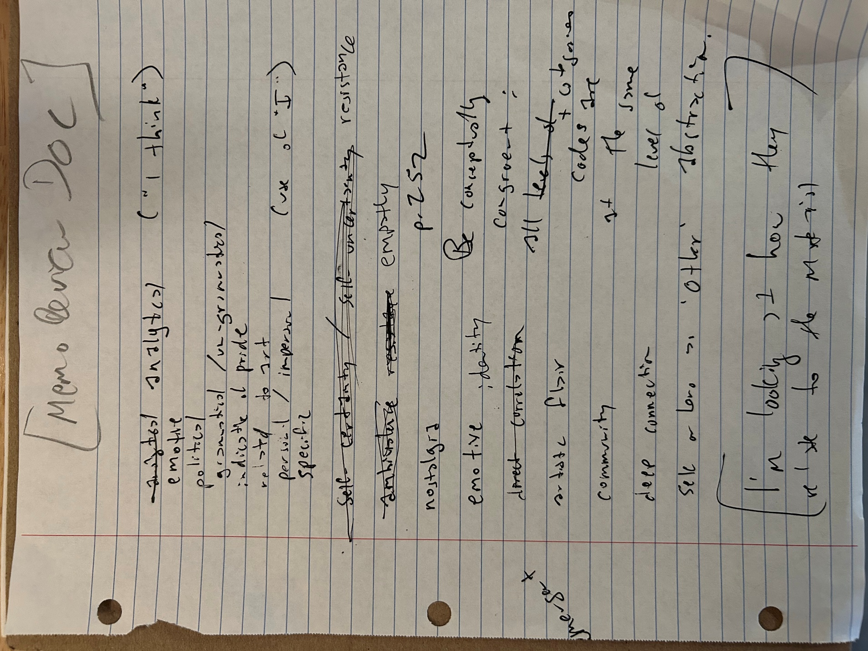
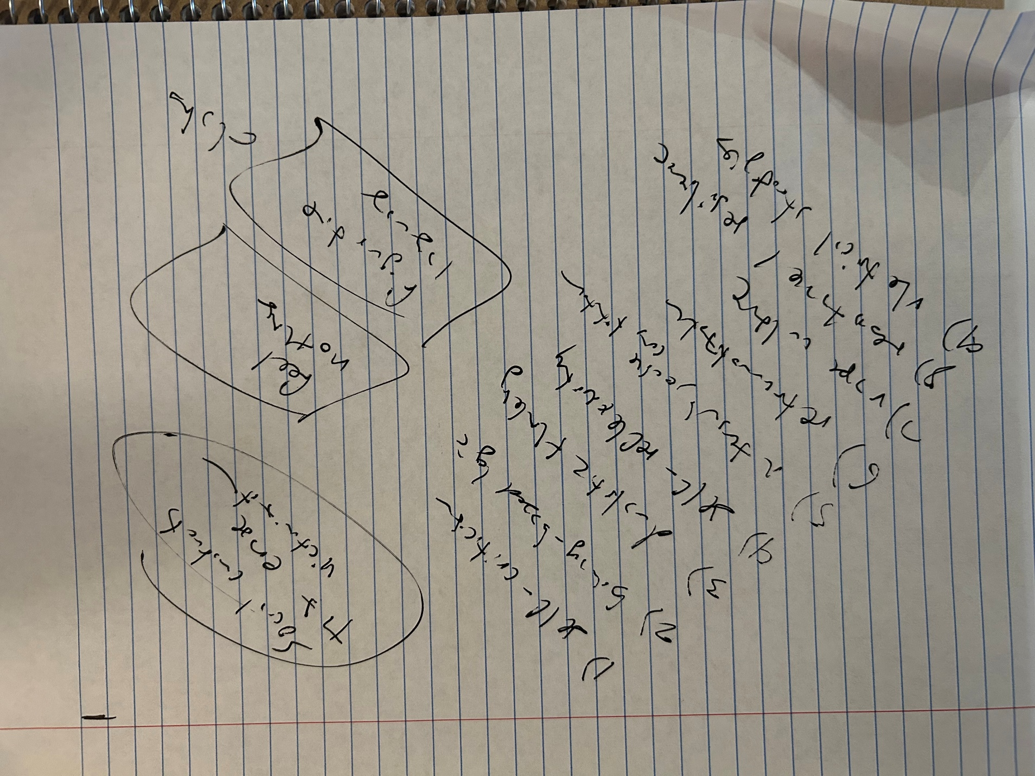
Initial Data Collection

Research Questions (may require some adjustment):
Is there really a (unusually attractive – may need to remove this language) pull of comics to queer people?

What shape does that take when extended into adulthood (clearly lots of grown-ups, including cishet ones, remain devoted to comics, but is it different for 2SLGBTQIA+ people)?

Is queer comics fandom, on balance, better or worse for agency, empowerment, and social enculturation?

THE PROJECT:
Questionnaire, Reflection on comics artifacts, open-ended “focus group” recorded interview
[First Cycle Open and Axial Coding Using color-coding based on the “progress” rainbow flag for 2SLGBTQIA+ people/ Salient categories determined upon reflection after the data collection and in corroboration with cohort colleagues Alisha, Alyssa, Julie, and Jocelyn]
resistance (against cisheteropatriarchal norms)
empathy
nostalgia
emotive
identity
artistic flair
community
depth of connection
self or hero as “Other”

“Lady Winter”:
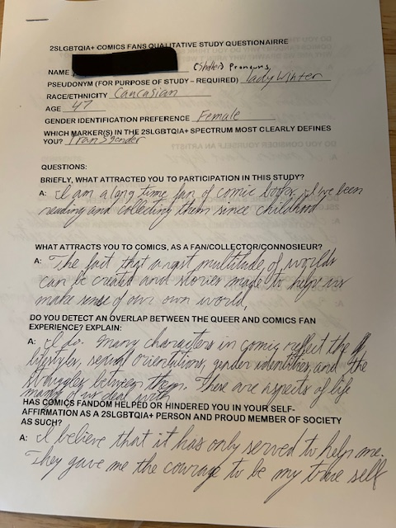
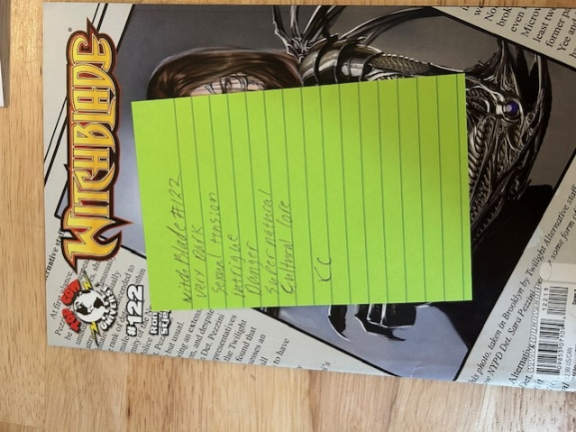
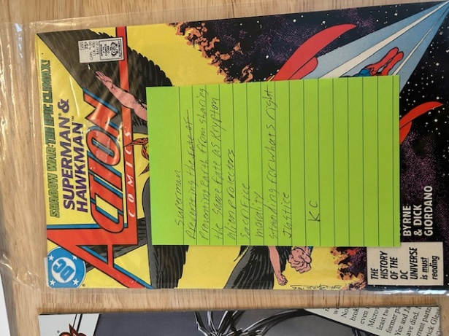
Name(Pseudonym): Lady Winter (she/her)
Race/Ethnicity: Caucasian
Age: 47
Gender Identification Preference: Female
Which marker(s) on the 2SLGBTQIA+ spectrum most clearly defines you?: Transgender
Questions
Briefly, what attracted you to participation in this study? A: “I am a long time fan of comic books. I’ve been reading and collecting them since childhood.”
What attracts you to comics as a fan/collector/connosieur? A: “The fact that a vast multitude of worlds can be created and stories made to help us make sense of our own world.”
Do you detect an overlap between the queer and comics fan experience? Explain. A: “I do. Many characters in comics reflect the lifestyles, sexual orientation, gender identities, and the struggles between them. They are aspects of life many of us deal with.
Has comics fandom helped or hindered you in your self-affirmation as a 2SLGBTQIA+ person and proud member of society as such? A: “I believe that it has only served to help me. They [comics] gave me the courage to be my true self.”
Do you think 2SLGBTQIA+ people in particular are drawn to comics fandom? Why do you think so, or why don’t you think so? Why are we drawn? Why aren’t we? A: “Seeing as that I’m a fan, I say yes, X-Men I believe is a good example. This adds some realism to a somewhat artificially constructed universe.” [/resistance code]
Do you consider yourself an artist? A: “I never have before.”
Do you think there’s an important connection between 2SLGBTQIA+ identity and being an artist? Why or why not? A: “I honestly don’t know one way or the other. I just know that I’ve always been creative.” [sub-code ambivalence]
Does the connection between comics and “queer joy” make sense to you? Why or why not? A: “Yes. Being able to see fictional characters having the freedom to be who they are is inspiring.”
What is “queer joy?” A: “Queer joy to me is deriving happiness from life that others shun or are afraid of.”
Finally, what results do you hope come of this study? A: “I hope that many more representations of the LGBTQ+ community are represented, and help create more understanding and lessen the hate/and stigma.”
Consents:
Consent to be interviewed: Yes.
Consent to be recorded: Yes.
Consent for AI transcription: Yes.
Consent for responses to be used in a limited academic study: Yes.
“Lady Winter”’s comics artifacts responses (post-its):
“Witchblade #122”:
Very dark
Sexual tension
Intrigue
Supernatural
Cultural core
“Action Comics #588: Superman and Hawkman”:
Preventing earth from sharing the same fate as Krypton
Alien protectors
Sacrifice
Morality
Standing for what’s right
Justice
“X-Men vs Apocalypse”:
Struggle for survival
Equality
Hate for difference between other humans
Characters fight for their place in the world
Proving worth
Strong female characters
Outsiders in conflict

“Ceres”:

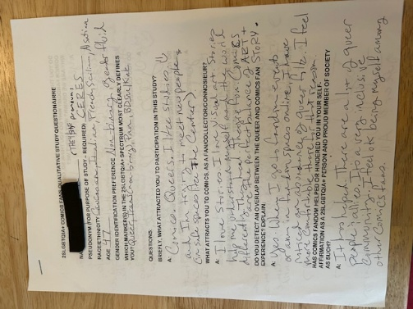
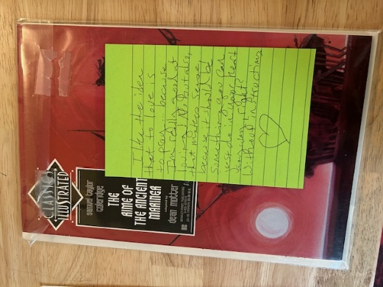
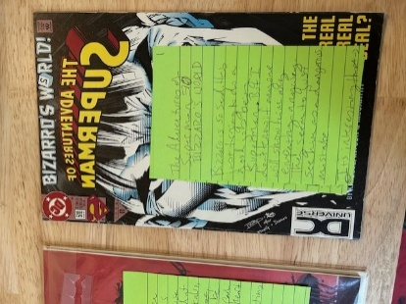
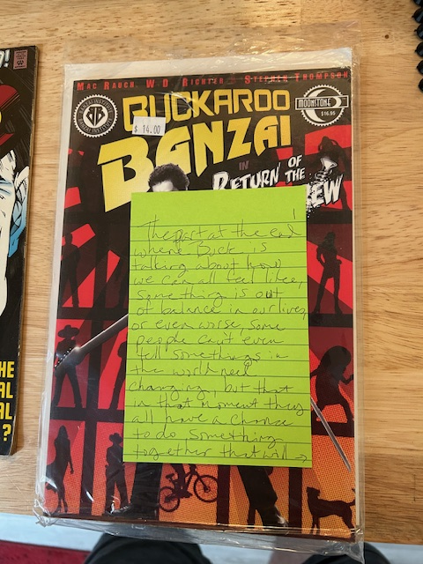

Name(Pseudonym): Ceres (they/she)
Race/Ethnicity: Caucasian, Italian, French, Sicilian, [another I had trouble reading “Alsatian?”]
Age: 47
Gender Identification Preference: Female
Which marker(s) on the 2SLGBTQIA+ spectrum most clearly defines you?: Non-binary, gender fluid
Questions
Briefly, what attracted you to participation in this study? A: “Comics. Queers. I like studies and I’m trying to meet new people (in safe spaces like the Center)”
What attracts you to comics as a fan/collector/connoisseur? A: A: “I love stories. I love visual art. Stories help me understand myself and the world differently. They heal. They’re fun. Comics are the perfect balance of ART + STORY.”
Do you detect an overlap between the queer and comics fan experience? Explain. A: “Yes. When I go to fandom events or am in fandom spaces online, I have noticed an abundance of queer folk. I feel more comfortable there for that reason.”
Has comics fandom helped or hindered you in your self-affirmation as a 2SLGBTQIA+ person and proud member of society as such? A: “It has helped. There are a lot of queer people & allies. It’s a very inclusive community. I feel ok being myself among other comics fans.”
Do you think 2SLGBTQIA+ people in particular are drawn to comics fandom? Why do you think so, or why don’t you think so? Why are we drawn? Why aren’t we? A: “Yes. I’m not sure, but I think one reason might have to do with the struggles of super heroes and villains. Like, I always related to Batman, Harley Quinn, Rogue, but like, because of their human struggles. The things they do as heroes or villains are choices, sometimes inspiring, sometimes warning. You know?”
Do you consider yourself an artist? A: “YES” “Writer, Visual Art, Most Art”
Do you think there’s an important connection between 2SLGBTQIA+ identity and being an artist? Why or why not? A: “Yes, because self-expression is so important to understanding yourself and communicating, and our community needs that so much. Also I think queer people are just drawn to art.”
Does the connection between comics and “queer joy” make sense to you? Why or why not? A: “Yes, because there’s a lot of inclusivity in comics, and a lot I can relate to even if it’s subtle sometimes. I feel quite a lot of queer joy in the comic world.”
What is “queer joy?” A: “Feeling joyfully queer? Joyful about queerness? Joyfully understood about being queer? All that.”
Finally, what results do you hope come of this study? A: “Hmmm. … more comics and more queers for everyone! I think this connection should be acknowledged and implemented by schools, parents … I mean give the queers comics, right?”
Consents:
Consent to be interviewed: Yes.
Consent to be recorded: Yes.
Consent for AI transcription: Yes.
Consent for responses to be used in a limited academic study: Yes.
“Ceres’s” comics artifacts responses (post-its):

“Classic Illustrated: Rime of the Ancient Mariner”:
I like the idea that to love is to pray … because I’m really good at loving!
No, but also that makes sense because it should be something you can just do in your heart
anyway, right? Without instructions.

“The Adventures of Superman: Bizarro’s World”
Bizzaro is so sad. He’s just trying to do a good job being Superman.
But I don’t know if anyone will show him any empathy anyway. They seem to just see him as a
dangerous mistake. It’s interesting that Bizarro thinks Lois should always be in danger, because it’s his job to save her. Ah, and the filing of sexual harassment lawsuits looks so easy here. If only it really worked like that. At the end, Lois tells Superman she doesn’t need to be saved. I wasn’t expecting Bizarro to be about this accidentally abusive Superman who wants Lois in damnger so he can save her. I like that she gets out of it on her own. I think the bit about sexual harassment at the news studio was well-intentioned but naïve. I like that it encourages women to report harassment, but it sets up an expectation for immediate justice. Oh. Wait. Right. Comic book. Ok. I guess it makes sense?
… but these kinds of stories weren’t helpful to me when reporting in real life [it] was actually really hard and no one listens to you.
“Buckaroo Banzai: Return of the Screw”
The part at the end where Buck is talking about how we can all feel like something is out of balance, or even worse, people can’t even tell something in the world needs changing, but that in the moment they all have a chance to do something together that will help; it’s how you show people they can help change the world. Also his talk about being adrift from our true natural course reminds me of transcendentalism.

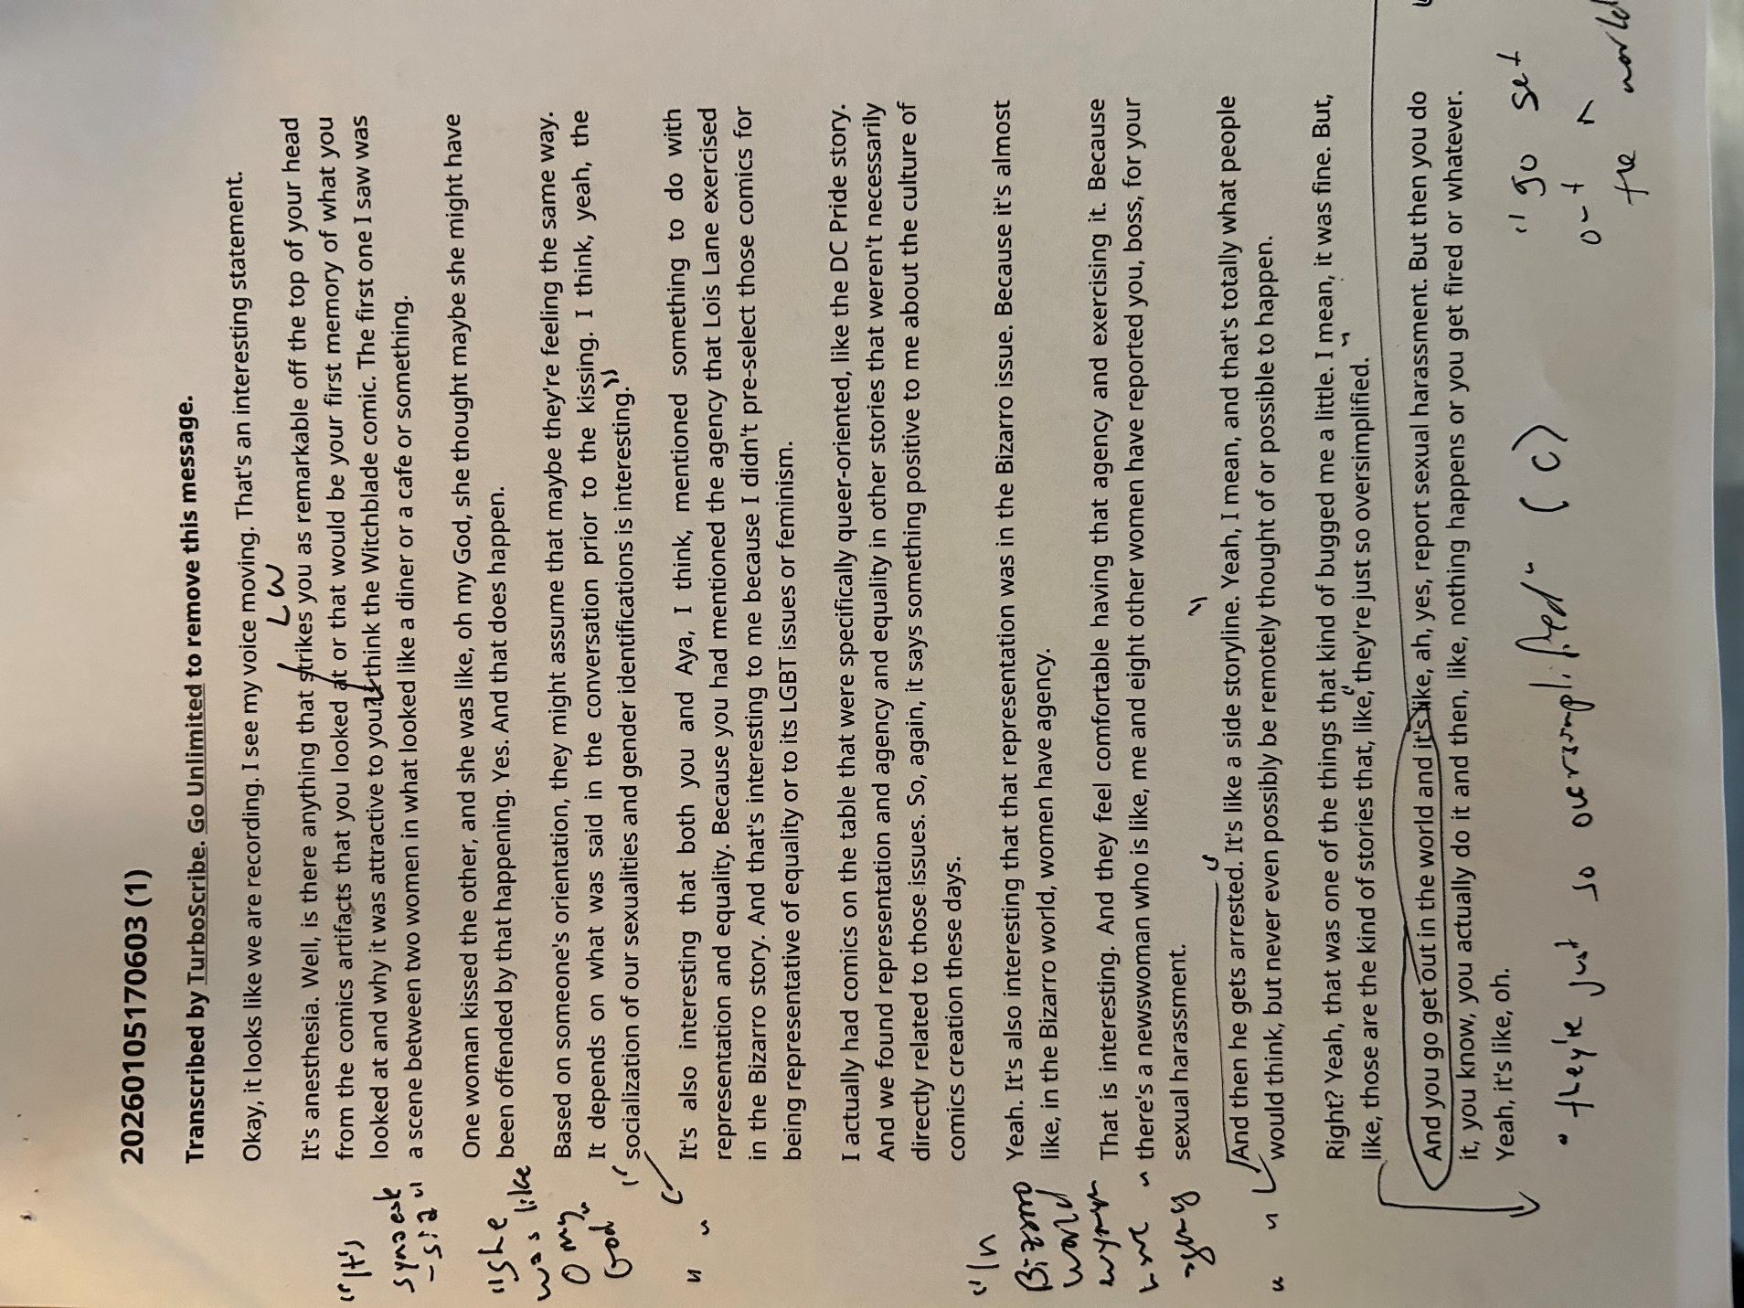
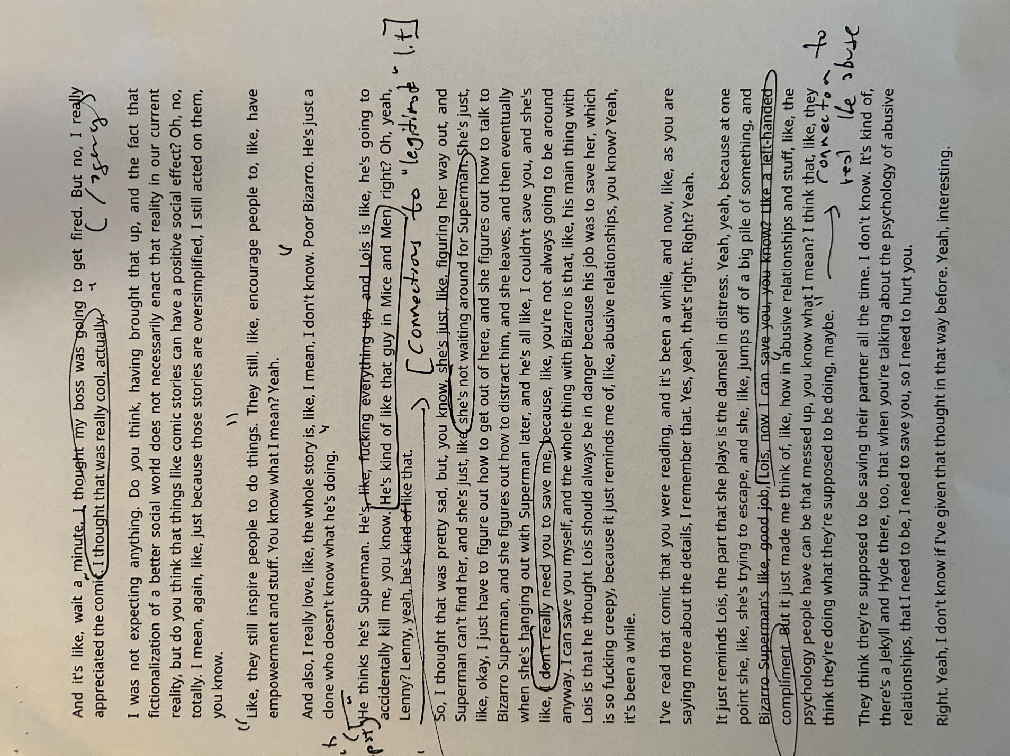
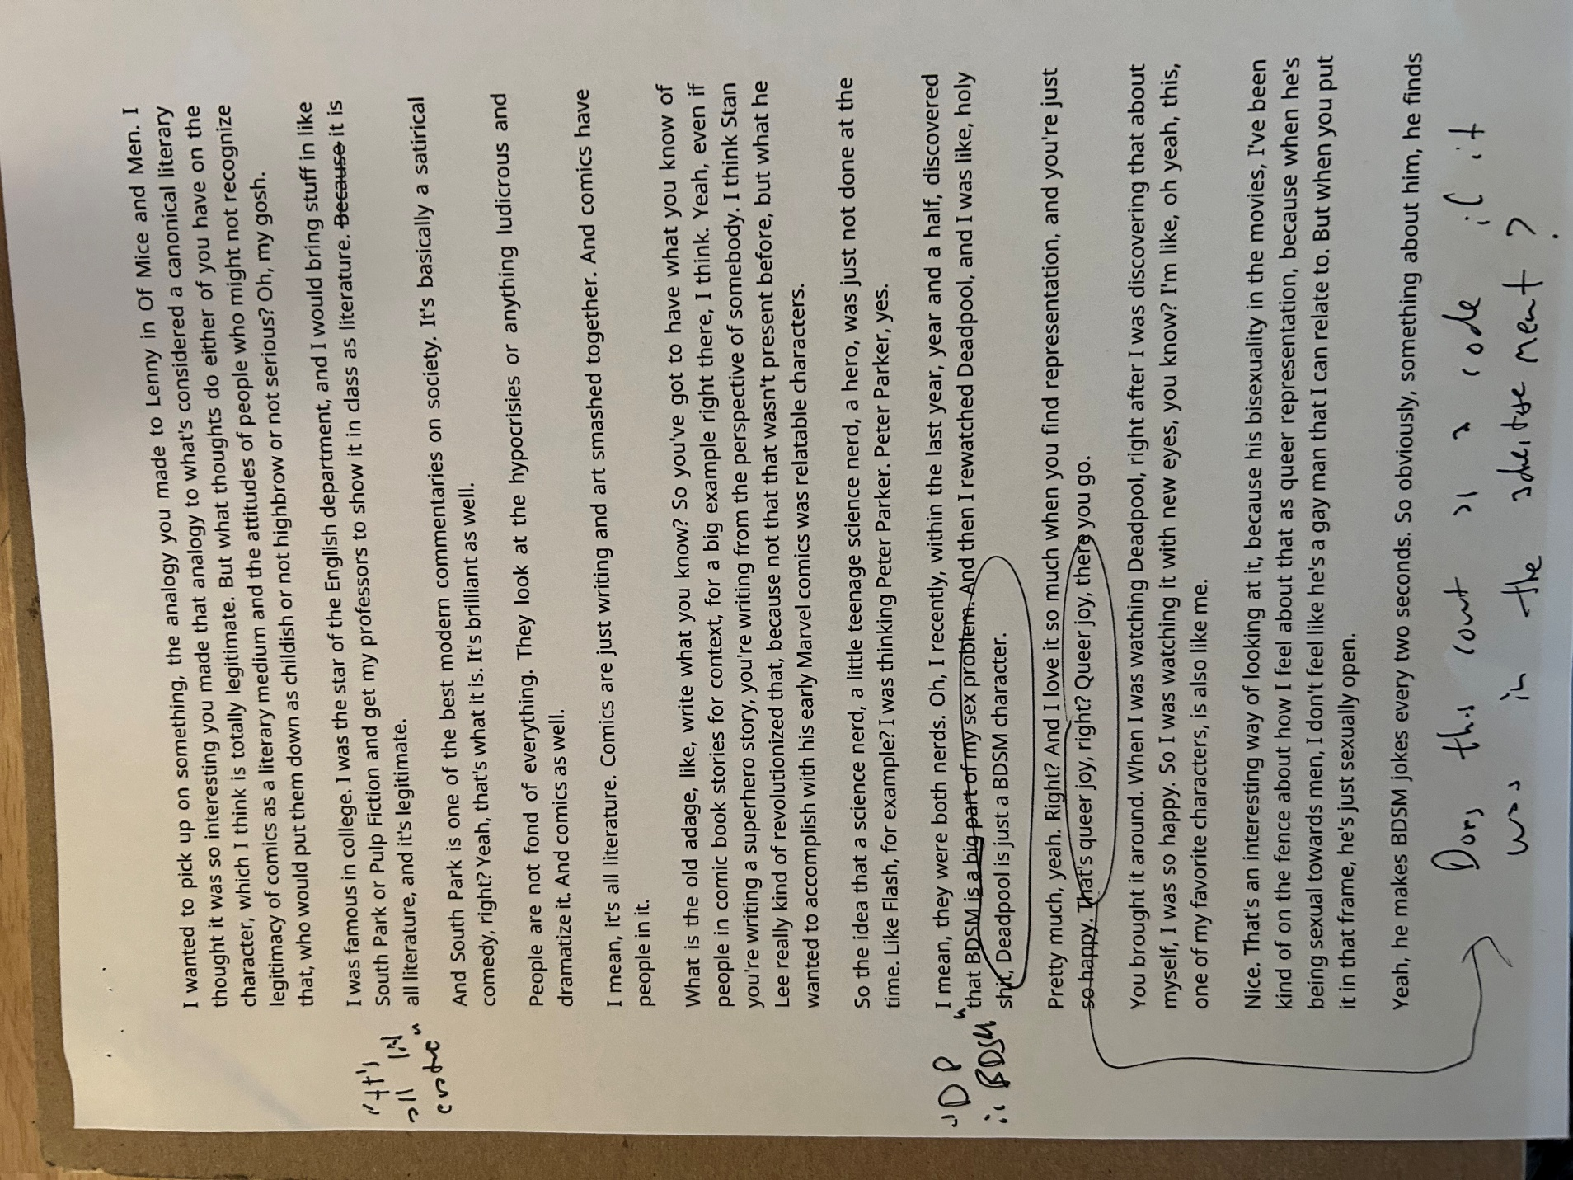
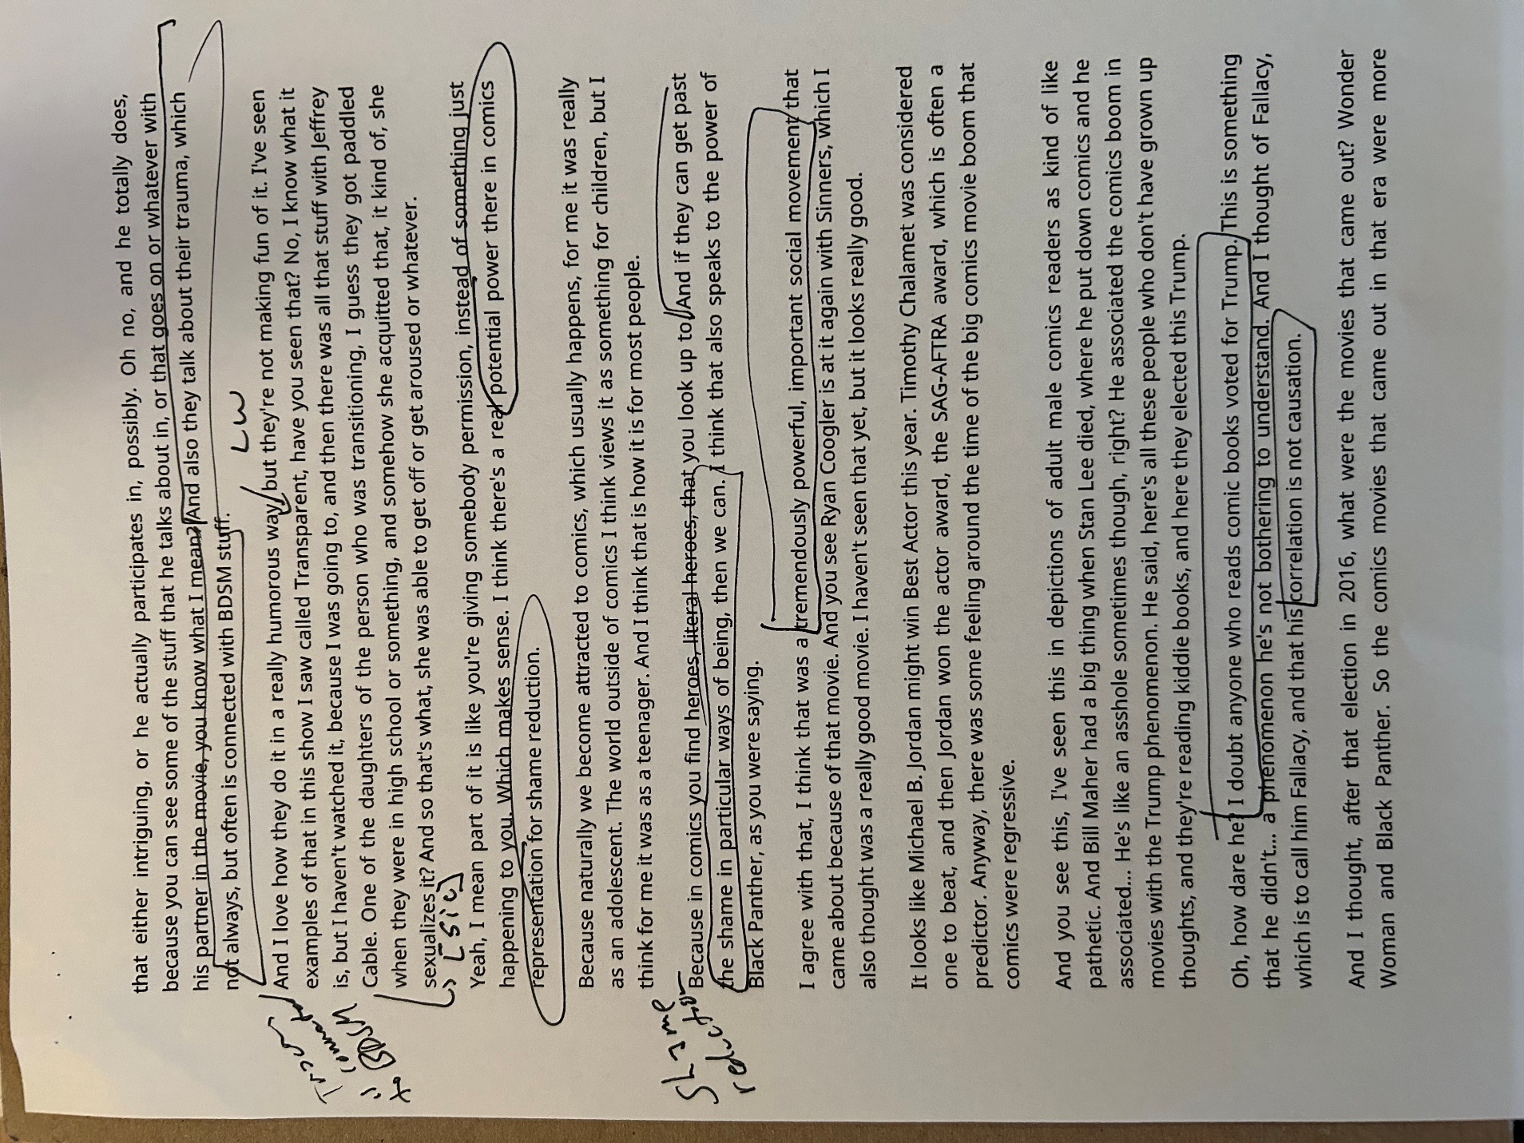
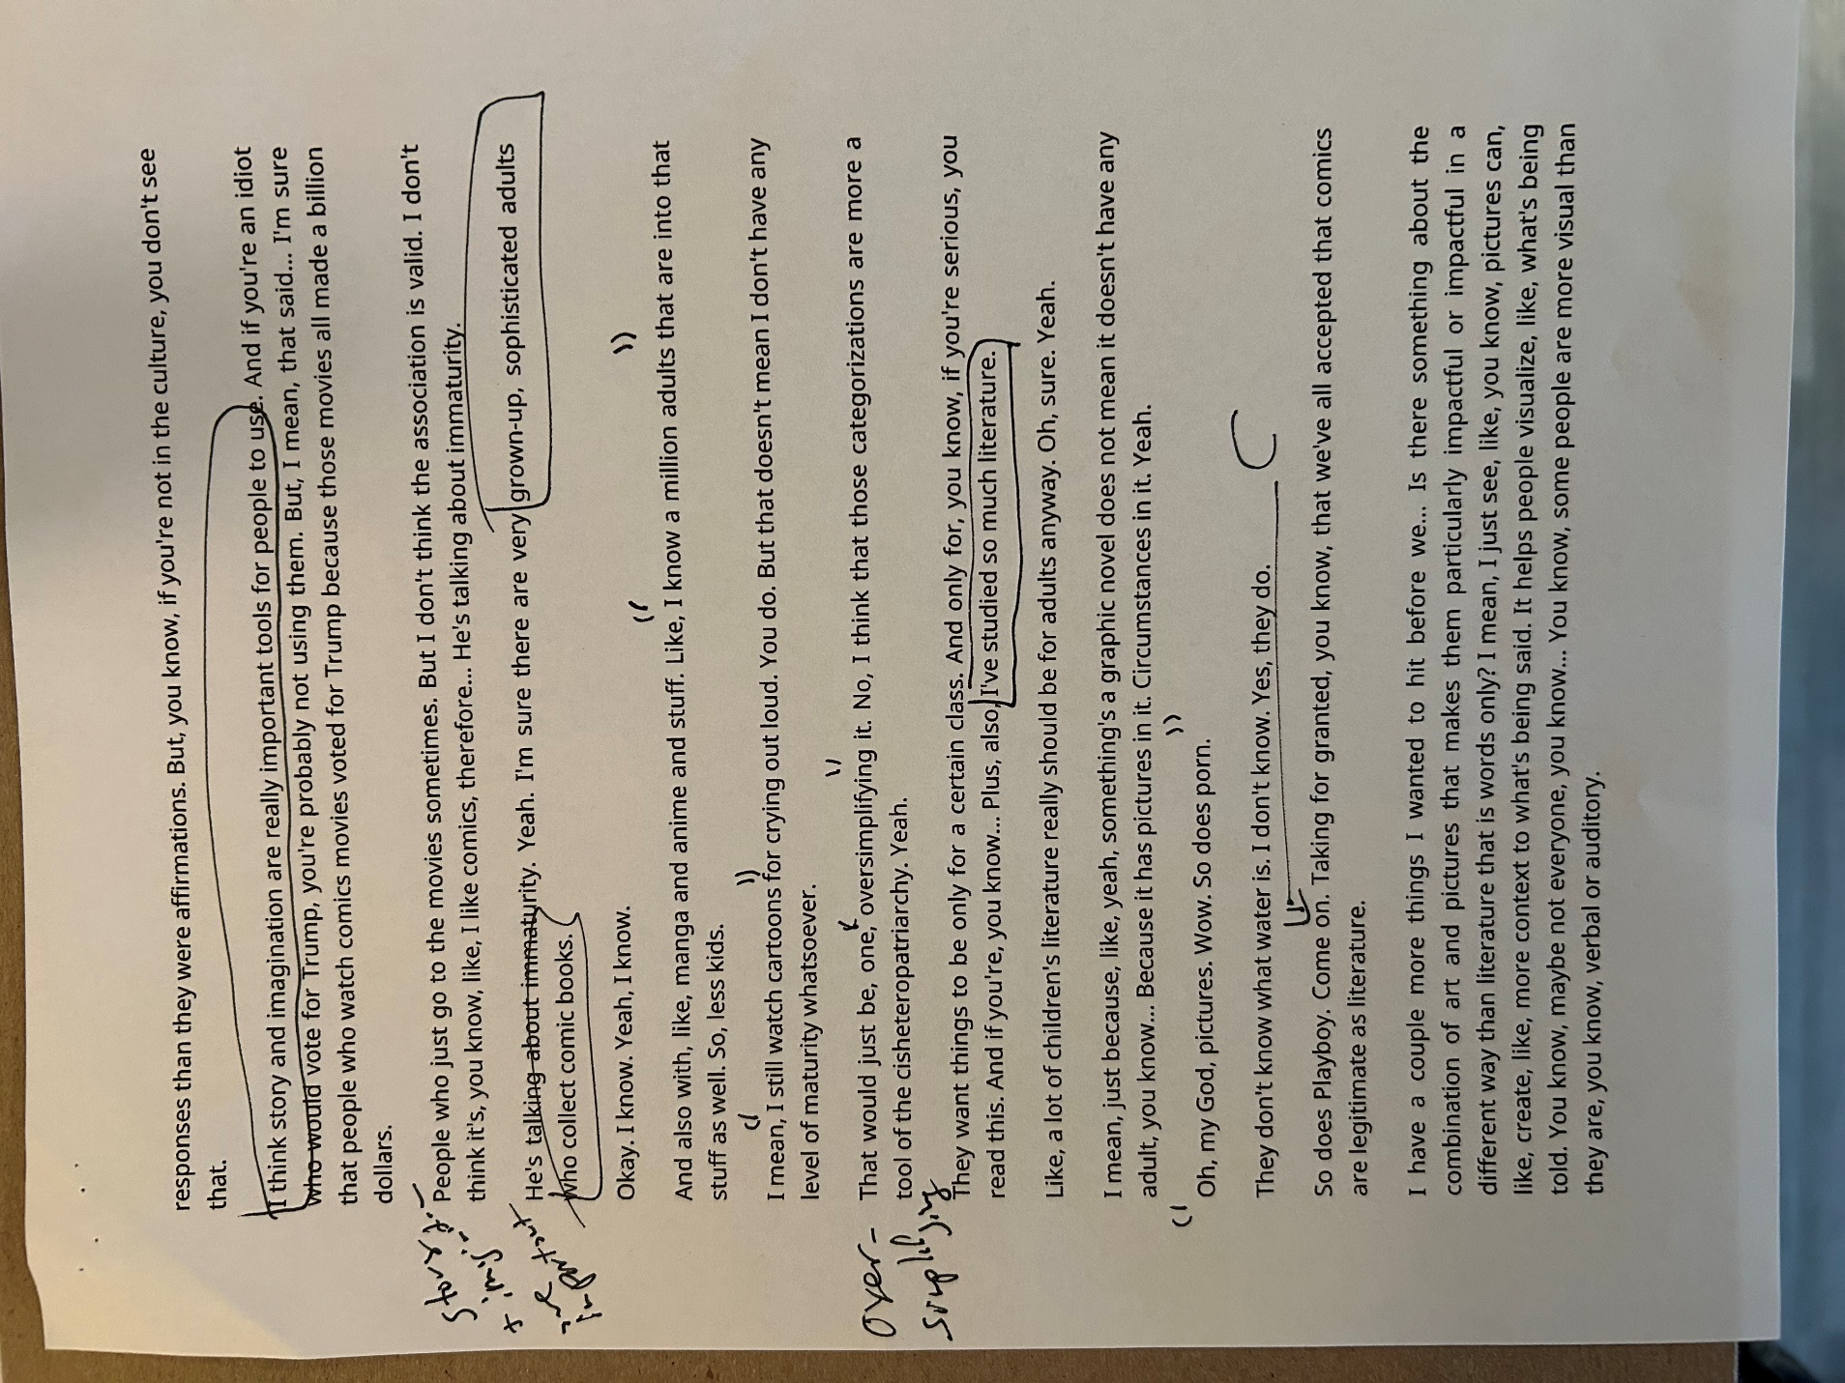
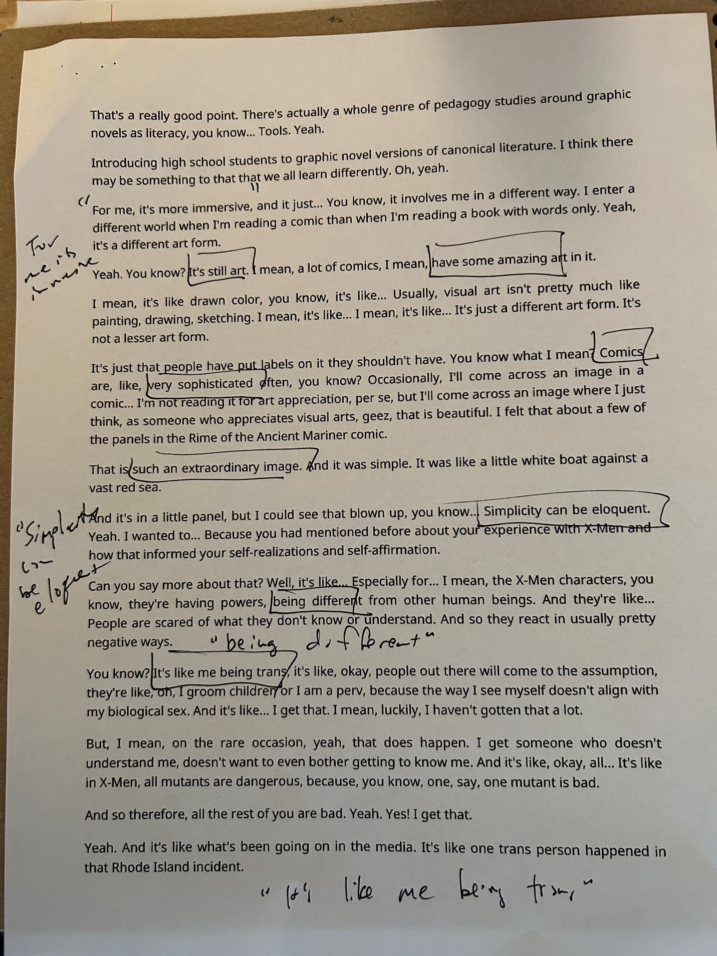
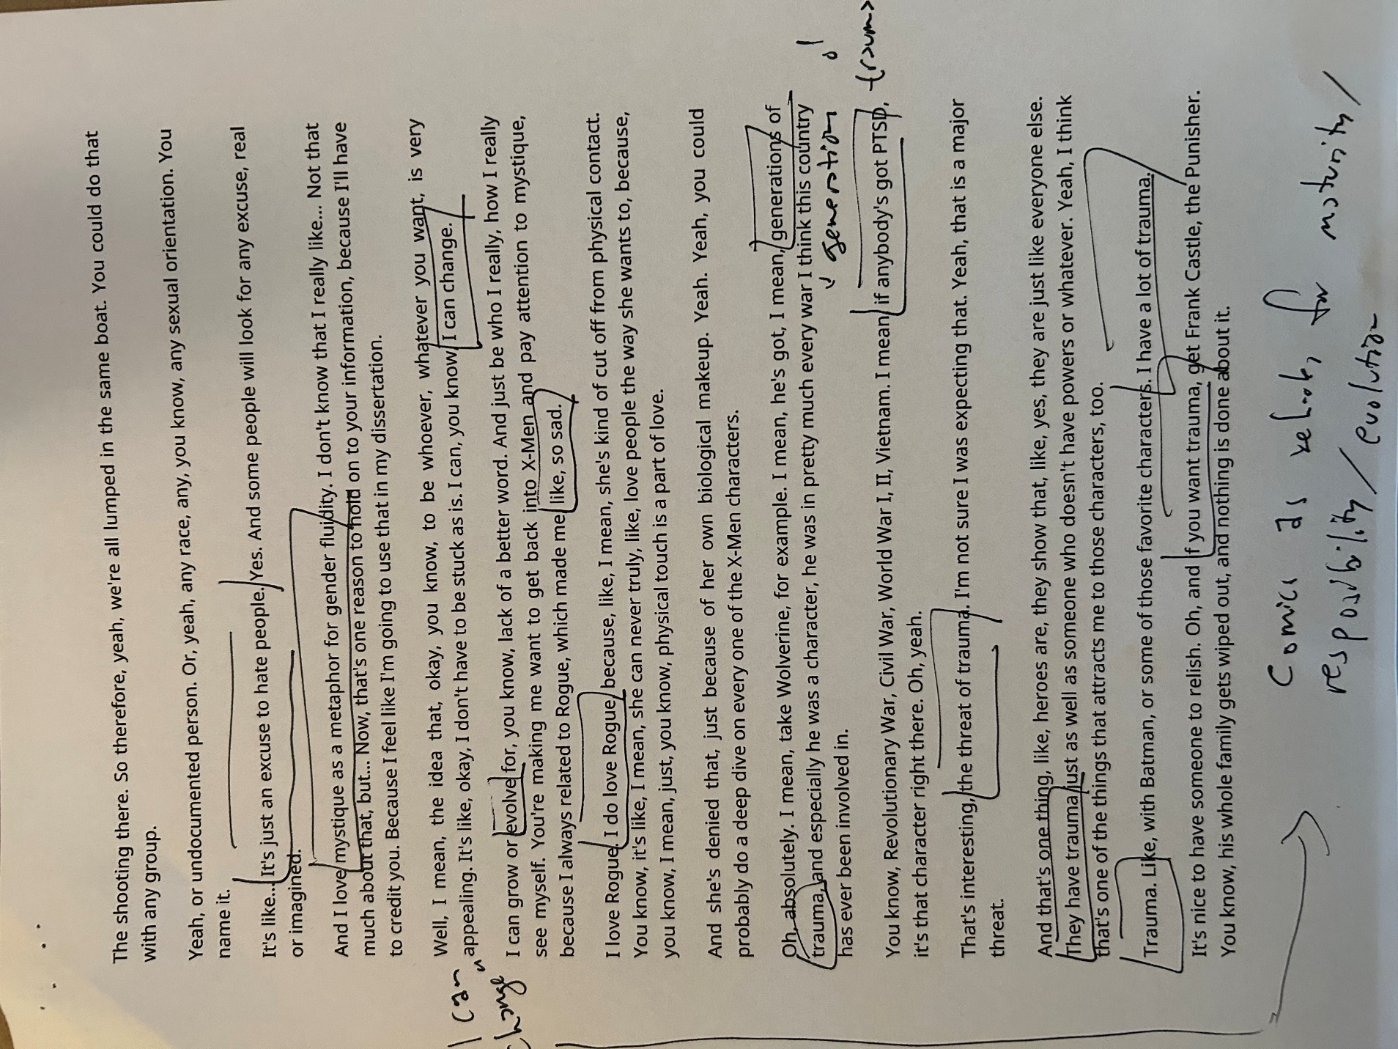
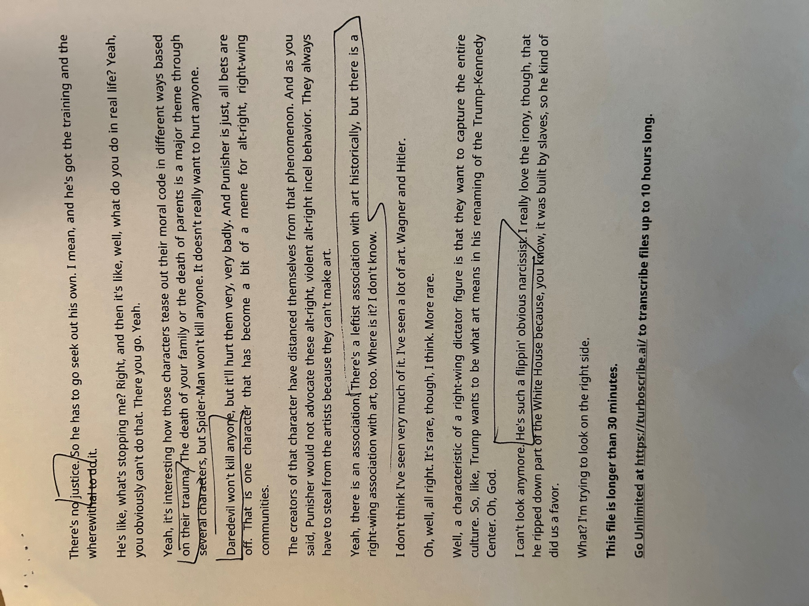

Research questions, format, and page numbers were applied directly from the brief created by Dr. Michelle Fowler-Amato.
This respondent tended to move back and forth between personal connection and generalization, an observation to revisit on a future round of coding perhaps.
Considered “ambivalence” as a code, but it didn’t seem to repeat as a theme often enough. Book-marking this response as well.
It’s worth noting that the post-it note responses could have constituted codes in their own right. They also might have been opportunities for “in vivo” coding. I felt that, by keeping the codes from the more formal questionnaire, the consistency in evaluation might reveal certain inconsistencies between how queer fans abstract their love of comics and how they engage in actual comics-reading.
This response was interesting because it was a mini-essay all on the space of one or two (large) post-its. It demonstrated how a comics story about an experience a fan knows about first hand can occasion both connection and disconnection. I wonder if “more conventional” literature would occasion a similar ambivalence, if the ambivalence is more down to having experienced the event or seeing it depicted in comics form. This Bizarro comics story was the artifact with which this particular respondent engaged most.

